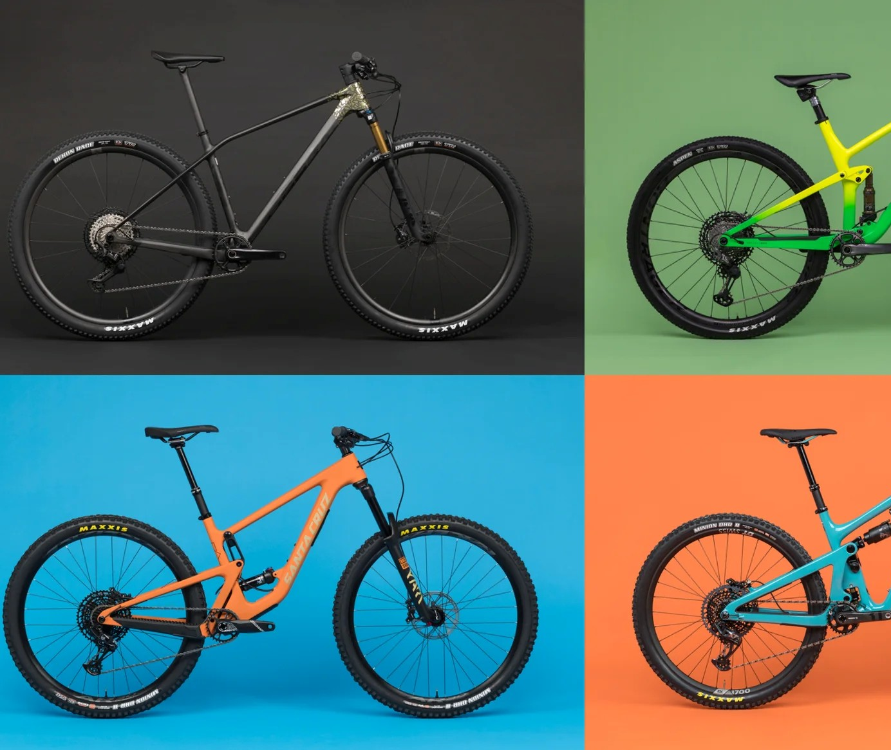

MTB Geometry Atlas
Identifying Mountain Bike Categories from Frame Geometry using Principal Component Analysis and Clustering

Saf Flatters · Timothy Bolt · Lizanne van Nieuwenhuizen
Contents
1 Introduction/Objectives 3
2 Methods 4
2.1 Data Cleaning 4
2.2 Exploration 4
2.3 Assumptions 5
2.3.1 Outliers 5
2.3.2 Correlation 5
2.3.3 Linearity 6
2.4 Principal Component Analysis 6
2.5 Unsupervised k-Means Clustering 6
2.6 R Package: ClustMixType with Mixed Data 6
2.7 Suspension travel-based Categories 8
2.8 Validation of Clusters 8
3 Results 9
3.1 PCA Results & Analysis 9
3.2 Unsupervised K-means Clustering Results 9
3.3 R Package: ClustMixType Results 11
3.4 Comparison of Clusters to Suspension Categories 13
4 Discussion 14
4.1 Interpretation of Results 14
4.2 Method Limitations & Data Assumptions 15
4.3 Comparison between Clustering Methods 15
5 Extension of Knowledge 16
5.1 Multi-class Support Vector Machine Classification 16
6 Conclusions 17
7 References 18
8 Appendices 19
8.1 PCA and Clustering Explanation 19
8.1.1 PCA 19
8.1.2 k-means Clustering 19
8.2 R Code 20

Introduction/Objectives
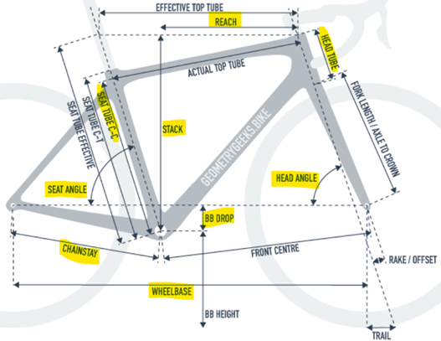
Mountain bikes are commonly marketed and categorised under broad riding styles such as “Cross-country”, “Trail”, “Enduro” and “Downhill”. These wildly accepted labels are often applied subjectively by manufacturers and may not always reflect the underlying geometry of the bikes themselves. This project aimed to investigate whether frame geometry alone can be used to uncover natural groupings, independent of predefined industry labels, and if these natural groupings are consistent with the predefined riding style labels used by manufacturers and mountain bikers.
Using the mtb-news.de.csv dataset, scraped from the MTB-News.de website and made available via the dorianprill GitHub repository (Prill, n.d.), 616 medium-sized mountain bike frames were analysed. The dataset contained 12 numeric geometry variables, of which 10 (reach, head tube angle, wheelbase, etc) were used for Principal Component Analysis (PCA). Clustering was then performed on this PCA dataset to determine the best configuration of natural groupings within the data. The two additional variables — front and rear suspension travel — were reserved for post-hoc validation.
PCA was applied to reduce the geometric variables into their highest variance explaining components. The loadings of these components were examined to determine what they physically meant, and then the most suitable components were selected. Unsupervised k-means clustering was then performed in this reduced PCA space to identify groups of bikes with similar traits. The elbow and silhouette methods were plotted and observed, and the clusters were visually analysed to determine the optimal value for k (number of clusters). Different clustering configurations were checked to determine which partitioning had the best, most distinguishable clusters, while still being elliptical in shape and having a considerable density of points. The results of the best k-means clustering solution was then reserved for validation.
Finally, we compared our clustering results with an alternative clustering approach using the ClustMixType R package. This method incorporated categorical variables such as brand and wheel size through the k-prototypes algorithm. The optimal number of clusters was determined through comparing total within cluster sum of squares, essentially a pseudo-elbow method, and visually by using clustering plots in a similar way to how the k-means clusters were observed. This comparison allowed us to assess the added value of including categorical information alongside geometry in identifying meaningful groupings of mountain bikes. The best solution found using k-prototypes was also reserved for later validation.
These geometry-based clusters were validated using front and rear suspension travel as a proxy for riding style. Although suspension travel is not a perfect classifier, it is a widely recognised indicator: Cross-country (front and rear: 100–130 mm, sometimes no rear), Trail (front and rear: 120–150 mm), Enduro (front and rear: 150–180 mm), and Downhill (front and rear: 180–200 mm+) (Schulberg & Czerwinski, 2022). From both sets of clustering results; our main goal was to determine the truth about the underlying structure of the mountain bike geometry dataset. Comparing the clustering results to the created riding style categories using contingency tables gave insight into how each cluster was related to riding style. Alluvial (Flow/Sankey charts) were also created to visually depict this relationship, allowing for clear interpretation.

Methods

Data Cleaning
The raw dataset was first filtered to retain only mountain bikes. Bikes with 26-inch wheels were removed, as this wheel size is now largely obsolete and would introduce unnecessary variation in frame geometry. The Year variable contained zero missing values, and rows with missing front suspension values were removed. Missing rear suspension values were assumed to represent hardtail bikes and therefore were set to zero. Columns with more than 1000 missing values were dropped, along with variables not directly relevant to geometry (e.g. URL, Category, and Frame.Config). To control for the effect of frame size, only Medium-sized bikes (labelled “M” or “Medium”) were retained. Rows with missing values in numeric columns were removed to ensure complete cases were used in the analysis.
After cleaning, the dataset contained 616 medium-sized mountain bike frames. Of the 18 variables retained, 13 were numeric. For PCA and clustering, 10 geometry-related numeric variables were considered, while Year and Suspension Travel values were excluded from PCA and reserved for post-hoc validation. The selected geometry variables were standardised, so each variable had mean 0 and standard deviation 1. This step ensured that variables measured on different scales (e.g. millimetres, degrees) contributed equally to PCA. The 5 categorical variables were removed from the numeric dataset and kept separate for later analysis (using the ClustMixType package).

Exploration
Density plots of the geometry and suspension variables showed a mix of symmetric, skewed and multimodal distributions. Many variables showed peaks around common geometries due to certain standards in industry. The multimodality (like in the Head Tube Length and Seat Tube Length) suggests subgroup structure in the data, making clustering appropriate. Since PCA is robust to moderate deviations from normality and clustering can be applied to non-normal data; no transformations were applied.
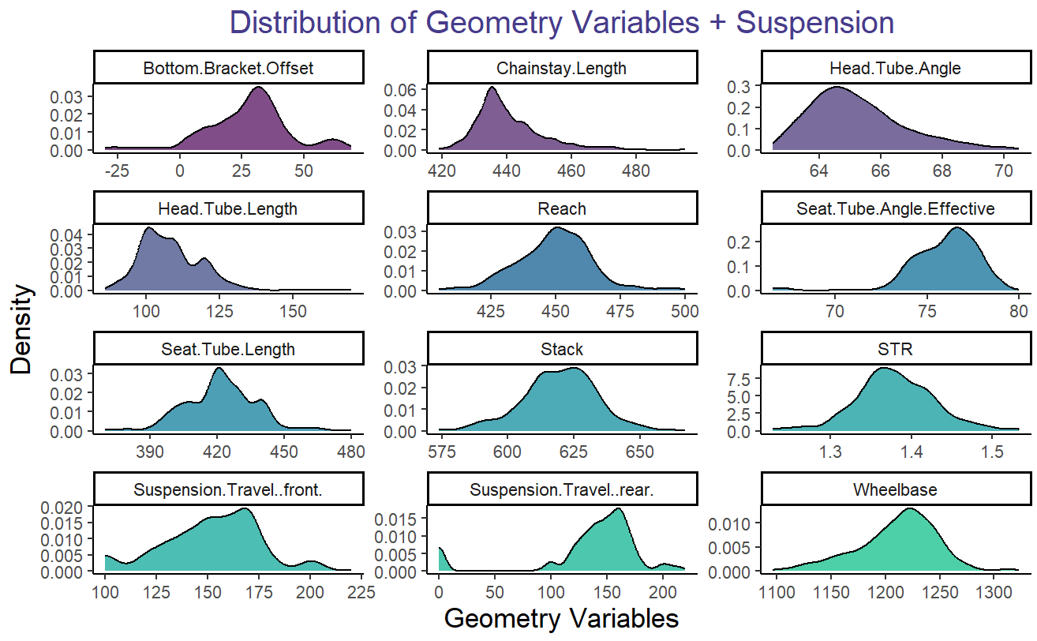

Assumptions

Outliers
Because the dataset was web-scraped, it was expected to contain errors and extreme values that might not reflect real bike designs. Outliers were checked in two ways.

Z-score thresholding:
Geometry variables were standardised, and any row with $∣z∣ > 7$ was flagged. Manual checking confirmed these five observations contained data entry errors (e.g. 2021 Giant Reign has 1000mm for Head Tube Length while the mean is 108.4mm). These were removed from both raw and scaled data frames.

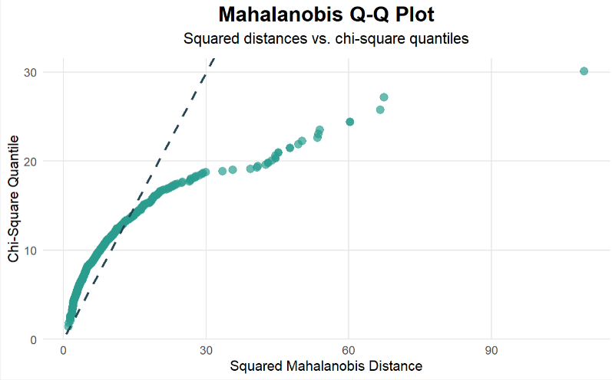
Multivariate diagnostics:
2022 Lapierre Prorace
The MVN package was used to assess outliers using Mahalanobis distance and diagnostic plots. Mahalanobis distance ${\left(x-\overline{x}\right)}^{T}S^{-1}\left(x-\overline{x}\right)$ was chosen over Euclidean distance for multivariate outlier detection as it accounted for correlation between bike geometry variables. The Mahalanobis Q-Q plot, which considers the combined geometry profile of each bike, highlighted one clear outlier — the 2022 Lapierre Prorace — with a distance of 10.455. This was removed to avoid distortion during PCA. The Q-Q plot also showed strong departures from the theoretical line, confirming the data are not multivariate normal. While PCA does not require normality, this suggests heavy-tailed behaviour and subgroup structure again supporting the belief that applying clustering will likely show underlying structure within the data. After removal of outliers, 610 bikes remained to be analysed.

Correlation
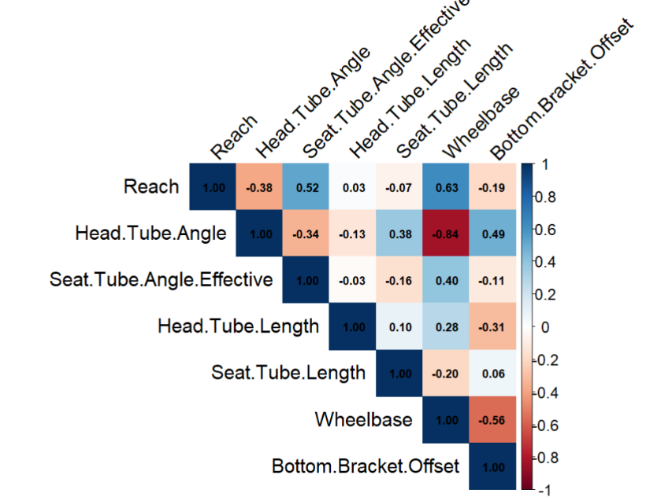
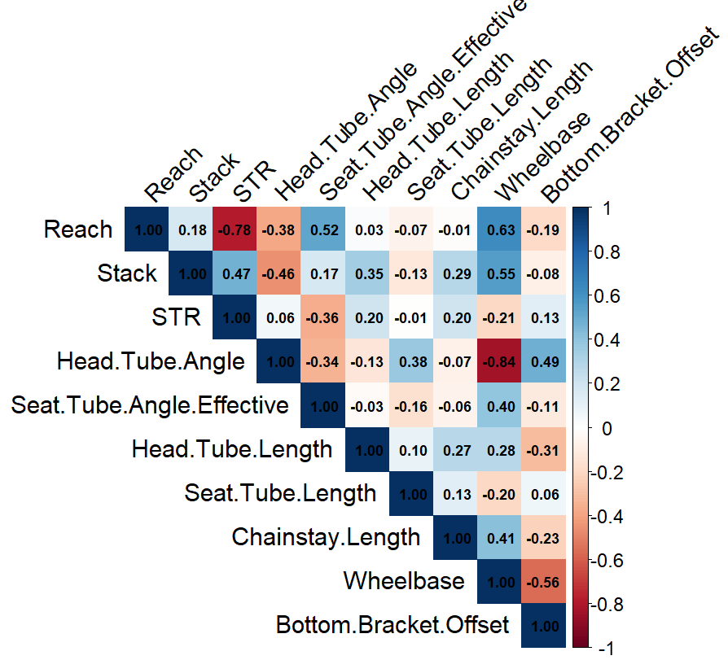
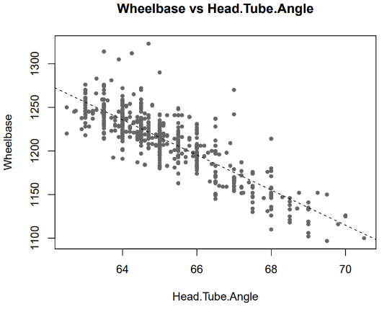
Unsurprisingly, the variance–covariance matrix showed large differences in scale (e.g. STR variance = 0.0023 vs. Wheelbase variance = 1338.07). A correlation heatmap (from the corrplot package) showed a mix of strong (e.g. wheelbase to head tube angle, $r$=−0.84) and weak relationships, raising some doubt about the strength of overall correlation. Bartlett’s test of sphericity was highly significant ($χ²=6961.72, p<0.001$), confirming sufficient correlation, however the KMO statistic was low (0.45), indicating weak sampling adequacy (Statistic with Jamovi, Session 4c: Factor Analysis, n.d.). To address this, we removed variables with poor adequacy or redundancy (Chainstay Length, STR and Stack), guided by the variable’s MSA (Measure of Sampling Adequacy) (Hamina, 2024). Recomputing the tests on the reduced set produced a cleaner correlation heatmap and an improved KMO (0.61), indicating better suitability for PCA.

Linearity
A scatterplot matrix was not practical for the number of variables we had. Instead, all pairwise scatterplots were exported to a PDF and checked manually. Most relationships (e.g. Wheelbase vs Head Tube Angle shown here) looked roughly linear, while some were weaker or less clear. Since PCA is robust to moderate deviations, we considered the linearity assumption to be met.

Principal Component Analysis
Using the princomp R package, PCA (see Appendix 8.1.1) was performed on the reduced geometry set (6 variables) using the correlation matrix to account for different units and variability. A table was created to easily interpret the eigenvalues, proportion of variance explained (PVE) and cumulative PVE. A scree plot was observed, and the Kaiser rule (λ>1) was applied to determine the optimal number of components. Loadings were inspected to identify which geometry measures drive each PC.

Unsupervised k-Means Clustering
k-means clustering was undertaken using the built-in k-means R function. This function applied the k-means algorithm (See Appendix 8.1.2) to the reduced PC space to find the optimal configuration of clusters for each provided k (number of clusters). An elbow plot was created for the subset to determine how the total within cluster sum of squares (TWCSS/TWSS) changed with each k, specifically the rate at which the TWCSS decreased and the point where it stopped decreasing rapidly (this is known as the elbow point). Other methods such as the silhouette and gap methods were computed and considered for values of k as well. This optimal k from these methods is only a suggestion, and if there is belief that another k is more suitable, it should be chosen.
Visually, clusters can be observed using scatterplots for the (top) two PCs selected for clustering. Using fviz_cluster from the factoextra package, we visualised the best k-means solution with 2D cluster plots. It is expected that clusters will overlap in this 2D space if clustering is performed on a higher dimensional subset of components, since these higher dimensions are not captured by just the first 2 PCs. This was not a problem in our investigation as only the top two PCs were considered for clustering. In these plots, ideal clusters are ones that look elliptical in shape, have a decent amount of observations/density of points, and are not touching neighbouring clusters meaning they are distinguishable from each other along boundaries.

R Package: ClustMixType with Mixed Data
Our analysis also explored the R package ClustMixType, specifically its kproto function that allowed for k-prototypes clustering, a multivariate clustering method for a mixture of numerical and categorical inputs. k-prototype clustering uses a distance function that accounts for both types of variables, corresponding to the “weighted sum of the Euclidean distance between two points in the metric space and the simple matching distance for categorical variables (i.e. the count of mismatches)” (Szepannek, 2018).
$$d_{k-proto}\left(x_{i},μ_{j}\right)=d_{euclid}\left(x_{i},μ_{j}\right)+λ d_{match}\left(x_{i},μ_{j}\right)=\sum_{m=1}^{q}{{\left({x_{i}}_{m}-{μ_{j}}_{m}\right)}^{2}}+λ\sum_{m=q+1}^{p}{δ\left({x_{i}}_{m},{μ_{j}}_{m}\right)}$$
Where the first q numeric variables and p (m-q) categorical variables account for all m variables. The $δ$ function returns 1 for matches and 0 for mismatches (between a point and a centre) and the $λ$ parameter controls the weight of the impact for categorical variables. The methodology for finding the optimal clusters is mostly the same as the k-means algorithm. Random clusters centres/means are decided, from which observations are assigned to their closest clusters (prototypes), and the clusters are then updated. This is repeated until an optimal configuration is found.
k-prototypes clustering was performed on the original reduced dataset before PCA was performed, due to the categorical variables being removed during the PCA process. Reinjecting these categorical variables back into the data after PCA was considered, but as PCA reduces dimensionality through variance observations, the variance captured by each categorical variable would not be present in the original PCs which could cause conflicts within a mixed dataset. Instead, the reduced dataset will be used for clustering. It should be noted that this reduced dataset is not standardised (unlike how PCA was performed on the correlation matrix). This is because standardising amounts to choosing a similar choice of weights ($λ$) that, although may sometimes be acceptable, is typically not ideal (Foss et. al., 2018). The kproto algorithm already determines an optimal weight from the data itself, hence standardising would potentially end up harming the clustering model more than helping it.
The optimal number of these clusters can be determined manually by creating a plot like the elbow method found for k-means clustering. This pseudo-elbow plot shows the change in total within cluster dissimilarity (TWCD), essentially a mixed-variate analogous for TWCSS, with the elbow point showing what the optimal number of clusters should be. Similar plots can be created for the silhouette and average explained dissimilarity of the k-prototype outputs for various k’s.
The ClustMixType package comes with an inbuilt plotting function 'clprofiles’ that shows how the different clusters vary across all the variables for a given kproto object. This results in boxplots that show the different spreads and skewness within each cluster for numeric variables, while histograms show the densities of each cluster within categorical variables. These plots are good to see an overview of the clusters, but they are not easy to draw conclusions from. Scatterplots were considered to compare two numerical variables, with the points being coloured by cluster, however this was deemed redundant as visual information was already encapsulated in the boxplots created using clprofiles and did not provide new insights into the data.
The best, most consistent way to visualise these new clusters was to use the same method used by the k-means clustering output. This meant plotting them against the first 2 PCs and colouring the clusters accordingly. As this cluster plot was manually constructed, there was no true clustering visualisation like what is possible with fviz_nclust. Instead, 90% ellipses were created to see the general spread of the data, which was confirmed to be very similar to the cluster polygons created using the k-means method.

Suspension travel-based Categories
Category | Front travel (mm) | Rear travel (mm)
Cross-country | 100–120 | ≤120 (or no rear)
Trail | 121–160 | ≤150
Enduro | 140–190 | 150–180
Downhill | ≥180 | ≥180
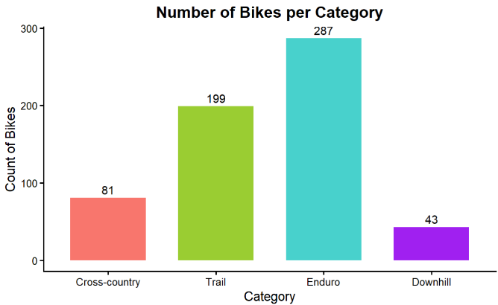
Using subject matter expertise, categories were created for later validation against clusters. Bikes were categorised by their suspensions into the industry-recognised categories: Cross Country, Trail, Enduro and Downhill. Out of 610 bikes (after removing outliers), only 14 bikes didn’t fit nicely into these categories. These were predominantly 160 front suspension, 140 rear suspension set ups. There were also a few non-standard travel sizes that had to be manually categorised and three bikes that had 190mm front suspension with 165/166 rear suspension. The categorisation rules were updated accordingly until all bikes were categorised, this has been summarised in the table. This resulted in 287 Enduro bikes, 199 Trail bikes, 81 Cross-Country bikes and 43 Downhill bikes.

Validation of Clusters
Once both optimal clustering methods were obtained, it was of interest to determine if these clusters were in any way similar to the pre-defined industry labels for bike categories due to riding style. This was done by creating a contingency matrix (Dantas, 2023) that determined the number of each category that fell into the different natural clusters, both as a count and a proportion of each cluster. This table could also be visualised as an alluvial plot (flow/Sankey chart) using ggalluvial. This plot clearly showed the weight/amount of each category that falls into each cluster, visually depicting any relationships that may be found between category and cluster. Comparisons between categories and clusters for each clustering method could then be made, answering the question of “if industry defined labels are truly determined by mountain bike geometries.”

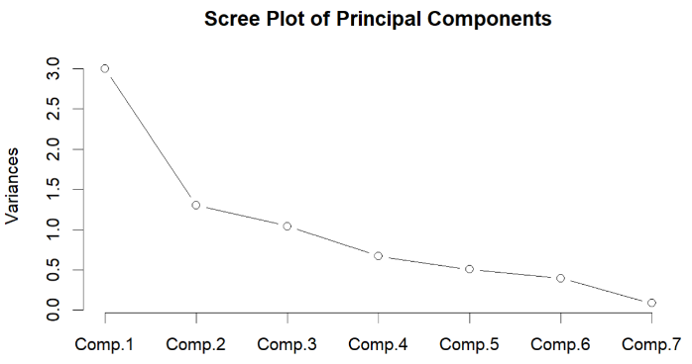
Results

PCA Results & Analysis
The first principal component accounted for 42.8% of the total variance, while the second and third components explained an additional 18.6% and 14.9%. The first three components captured 76.3% of the variance. Examination of the loadings shows that PC1 is mainly driven reach and wheelbase (positive loadings) and head tube angle (negative loading). This suggests PC1 represents a “slack geometry” axis. PC2 is influenced by effective head tube length, seat tube angle, and bottom bracket offset, this could be considered as a reflection of rider position. PC3 is dominated by seat tube length, likely capturing frame sizing. The third component did not represent a meaningful geometry axis, but rather minor size variation among medium frames across brands and was therefore not considered further in our analysis.
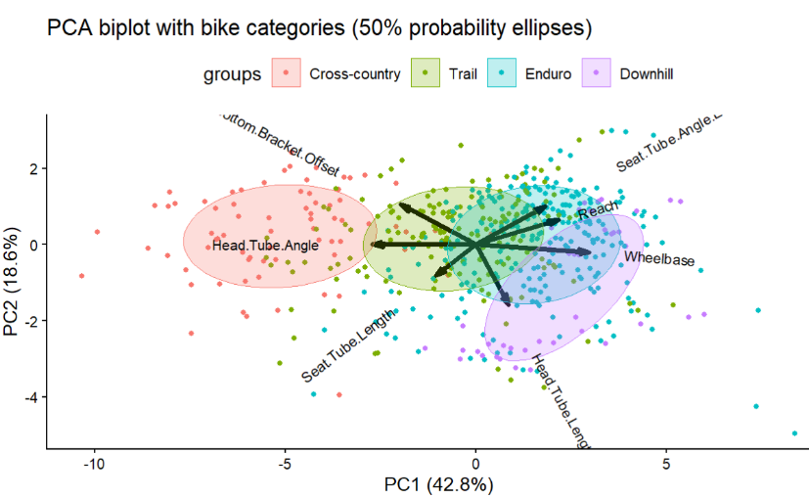
A biplot of the first two principal components was created with ggbiplot. Each bike is shown as a point, and the arrows show which geometry features contribute most to the components. To make patterns clearer, the bikes were coloured by category (Cross-country, Trail, Enduro, Downhill). Ellipses mark the spread of each group (50% confidence region), so we can see where categories overlap and where they separate. This helped us check how well the first two components capture variation in geometry and whether the categories form distinct clusters. As seen from the plot, clear definition was found for Cross Country bikes, clearly forming their own ‘cluster’. The three other suspension categories were more mixed.

Unsupervised K-means Clustering Results
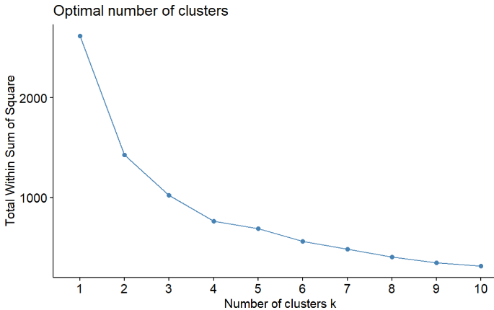
k-means clustering was applied to the reduced PCA dataset (a subset of the strongest two PCs) to determine the best natural groupings of mountain bike geometries. By only clustering on two PCs. Scatterplots on these two axes clearly visualised the clusters, which were separated by colour. The elbow plot appears to elbow at k=4, assuming the elbow point itself is included in the optimal clustering configuration. The silhouette and gap methods were also computed. These gave different optimal choices for k, k=2 and k=1 respectively, indicating that clustering was weak/overlapping for these methods. This indicated that minimal to no clustering was needed to show underlying grouping in the data. As these plots gave conflicting results, cluster groupings from 2-7 were visually analysed to see which was the optimal number of clusters instead. The optimal cluster grouping was decided by determining which k gave the most distinct groups, while still trying to limit the number of clusters and while ensuring clusters were elliptical in shape.
Two clusters split the data in half evenly, with there being an obvious vertical central border along the split. The clusters appeared to be touching along this border. These clusters were very large and sparse (compared to their size), meaning it was difficult to make conclusions about what the clusters represented. This meant these clusters were not considered a suitable clustering configuration.
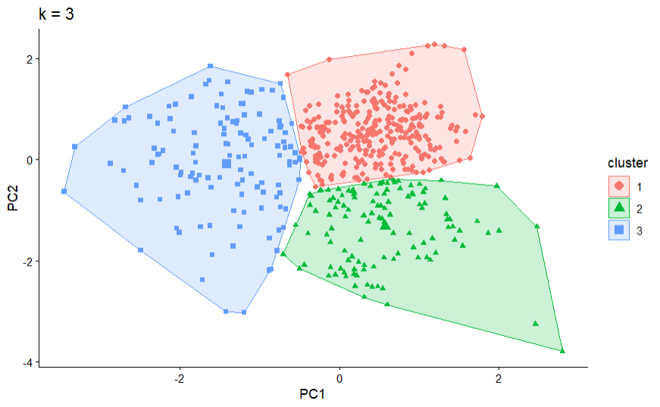
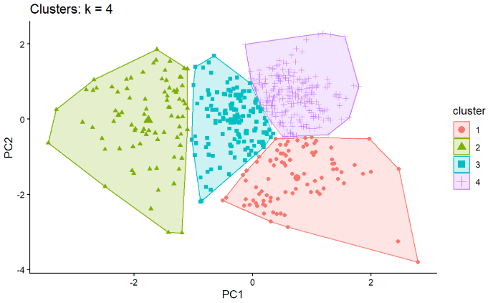
Three clusters showed a similar split to the two-cluster scenario (with the right cluster now split horizontally in half). These clusters were tightly packed, making it hard to distinguish them along their borders. Cluster 1 was very dense, while clusters 2 and 3 were much sparser. As more than half the clusters were problematic, this configuration was deemed unsuitable.
Four clusters, the optimal number from the elbow plot, showed one strong distinct cluster (cluster 2). The other 3 clusters were all very close together and converged to a centre point. This is the same point that was identified as the horizontal split line in the 3-cluster scenario/the centre of the right cluster in the 2-cluster scenario. This clustering was deemed problematic due to the difficulties when distinguishing between clusters 1, 2, and 4.
As the previous 3 partitioning results (k=2, 3, 4) were deemed unsuitable, larger values for k were calculated and observed. Both the 5 and 6 cluster groupings were checked. These produced similar cluster plots, but the gaps between the clusters were larger and the overall shape of the clusters was more circular in the k=6 case.
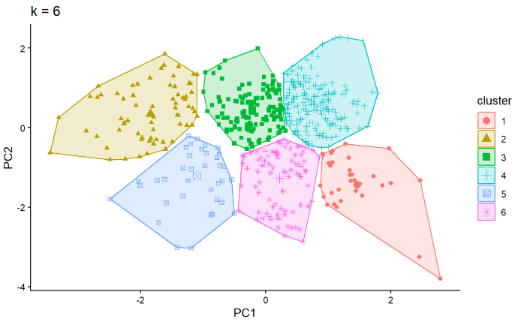
Higher orders of clusters were considered and observed, specifically the range from 7 to 15. As these clusters became smaller and more localised, they didn’t contribute any additional meaningful information. Instead, these clustering’s kept subdividing known clusters, in turn decreasing the number of observations per cluster and becoming harder to interpret. A goal was also to limit the total number of clusters; hence these were not considered for our final choice.
The top right region was known to have a very dense grouping of points, as was seen in a preliminary viewing of the data on the first 2 PCs. This was identified as the reason for very close clusters in this region. The goal with k-means clustering was to find a set of clusters that best divided the points into clearly separate groups, however leniency was given to clusters in this top right region. This led to the decision that the optimal number of clusters for the PCA data was 6 clusters. Upon a second viewing of the elbow plot, the point for k=6 was identified as a ‘second’ elbow in the plot, confirming our suspicions that 6 clusters could be considered as the optimal number of clusters for the data.

R Package: ClustMixType Results
ClustMixType is an R package that allows for clustering mixed datasets using the k-prototypes clustering algorithm. The mountain bike geometries dataset had 5 categorical variables that were considered for clustering: Brand, Model, Year, Motorized, and Wheel.Size. By checking the number of levels associated with each categorical variable and comparing them to the number of observations in the dataset, it was possible to determine which variables would be useful for clustering. Model had an extreme number of levels (448), Brand had 91 levels, Year had 11 levels, Wheel.Size had 3 levels, and motorized (was a binary variable) that only had 2 levels. Comparing this to the 610 observations in the dataset, Model was deemed unhelpful for clustering due to there being too many levels (unique models). All other categorical variables were kept and type-cast into factors. To truly know which variables should be used in an analysis, consultation with an industry expert for mountain bikes would be required. The final mixed dataset used a combination of the 6 best numerical variables (originally used for PCA) and the 4 categorical variables deemed suitable.
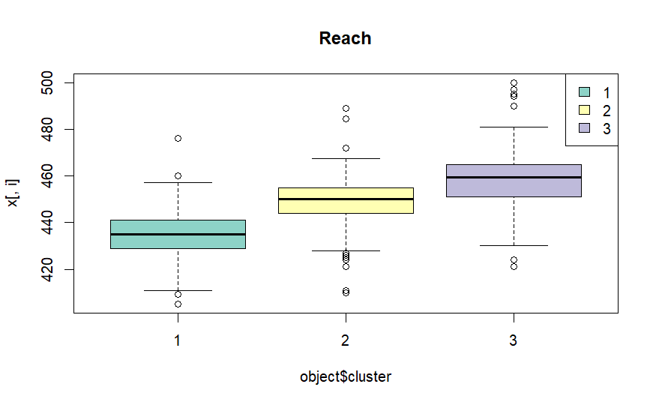
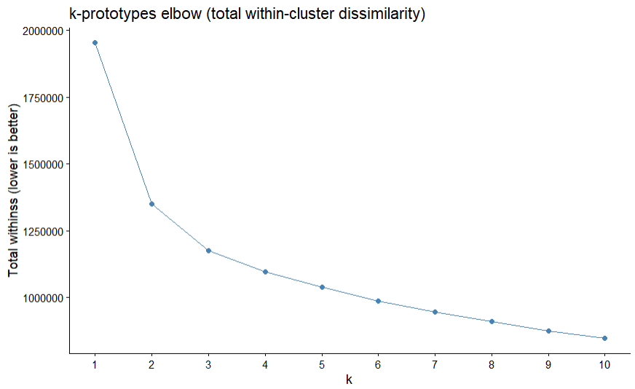
To determine the optimal number of clusters, as there are no inbuilt methods, the TWSS was calculated for a range of k’s and then plotted to see how increasing the number of clusters decreased the TWSS, this could be considered a pseudo-elbow method (Szepannek, 2018). To keep consistent with the k-means elbow plot, 1 to 10 k-prototypes clusters were created and their TWSS recorded. The elbow for this plot seemed to occur at k=3. Other mixed-variate clustering diagnostic plots were created, such as a pseudo-silhouette plot (using Gower distance) and an average explained dissimilarity plot, these showed optimal values of k=3 and k=4 respectively. It was decided that 3, 4 and 6 clusters should be examined to see what their partition’s look like, as well as how these clusters compare to those found using k-means.
The clprofiles plots were observed for each of the different cluster configurations. It was found that typically there was an unordered linear trend exhibited by the different cluster centroids (representative of the means for each boxplot). The variances stayed consistent per cluster, and categorical variables typically had a primary value associated with each cluster. Due to the nature of these plots, it was difficult to determine generic trends exhibited by the clusters. To make visualisations comparable to the outputs found by k-means, the two optimal PCs were reinserted into the mixed dataset and used purely for visualisation of the created clusters. This made generic observational differences noticeable again. Due to the fact that the data used for PCA is part of the mixed dataset (original numeric geometric variables), the PVE explained by each PC should still hold somewhat true. Only now accounting for a smaller amount of variance as the categorical variables have extra variance that was not accounted for during PCA.
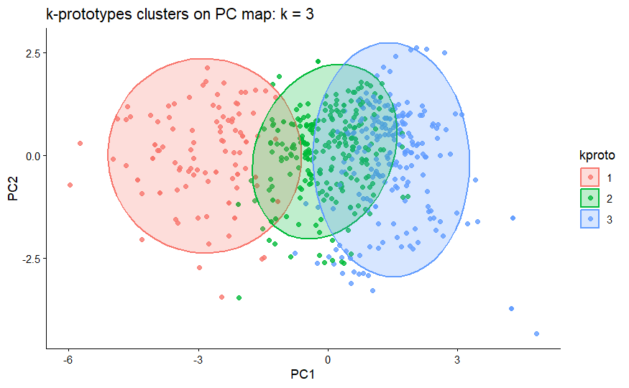
Similar to the k-means results, optimal clustering configurations were observed and critiqued. three clusters showed the most obviously distinct clusters when plotted against the best PCs. Cluster 1 was to the most separate, with clusters 2 and 3 overlapping significantly in the middle dense region of points. There is likely a higher dimensional clustering that is not visually apparent from the PCs map.
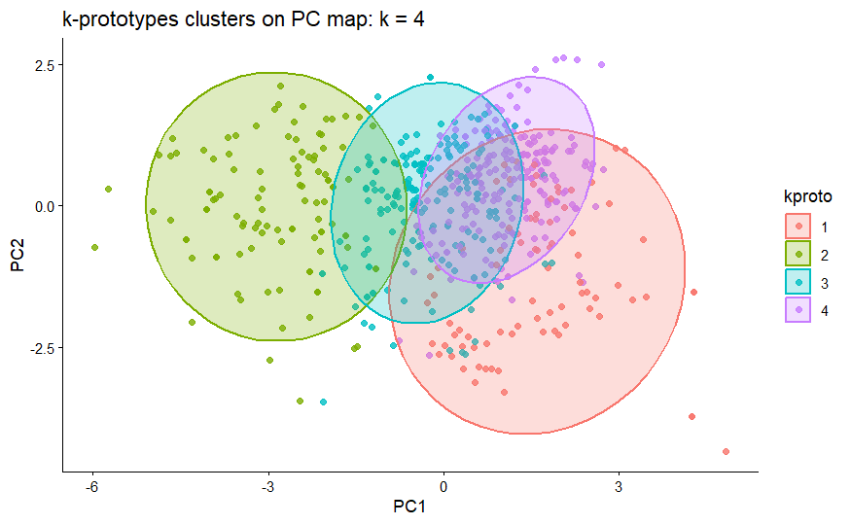
four clusters showed a similar output to the three clusters case (especially comparing clusters 1 and 2 for k=3 to clusters 2 and 3 in k=4). What was cluster 3 has now been split into cluster 4 (small and compact) and cluster 1 (wide and empty). Due to the sparsity of cluster 1 for its size, the k=4 case was deemed not a strong fit for clustering (assuming this sparsity holds true for all dimensions).
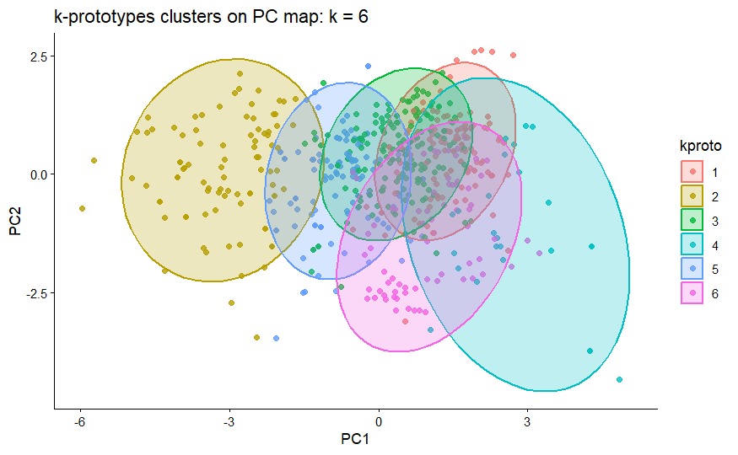
The six cluster case was also observed and compared to the k=6 configuration for k-means. The far-left cluster (cluster 2) still seemed separate from the other clusters indicating it was a clear group regardless of clustering choice. The other clusters seemed to overlap in a central region on the PC plot. All clusters appeared to have a very compact and localised shape, except for cluster 4 which was sparsely distributed (especially for its large size). This is likely due to the points within the cluster all having some specific common feature (likely a categorical similarity) that was not captured by the PCs meaning this cluster appears somewhat randomly when observed here.
The choice for the optimal number of clusters for k-prototypes mixed clustering was difficult to determine, especially due to there being no clear way to visualise the generic differences between different clustering configurations. It was decided that using the elbow plot to choose the optimal clustering of k=3 was the most suitable decision. A benefit of choosing the k=3 clustering configuration was that it had the most visually distinct of the clusters observed in the plots, making interpretation slightly easier.

Comparison of Clusters to Suspension Categories
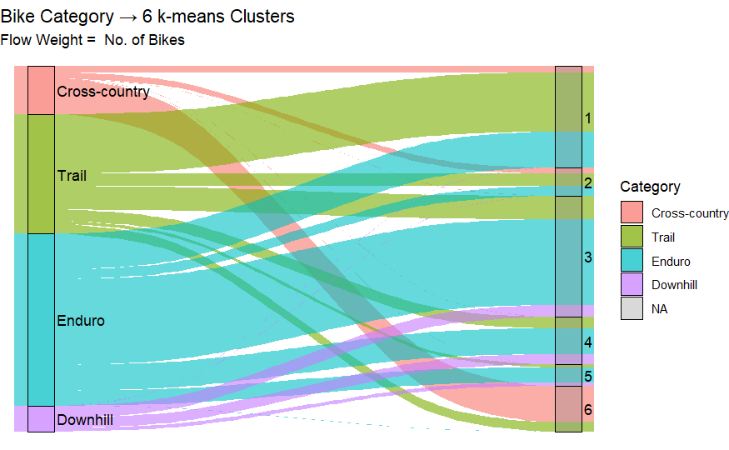
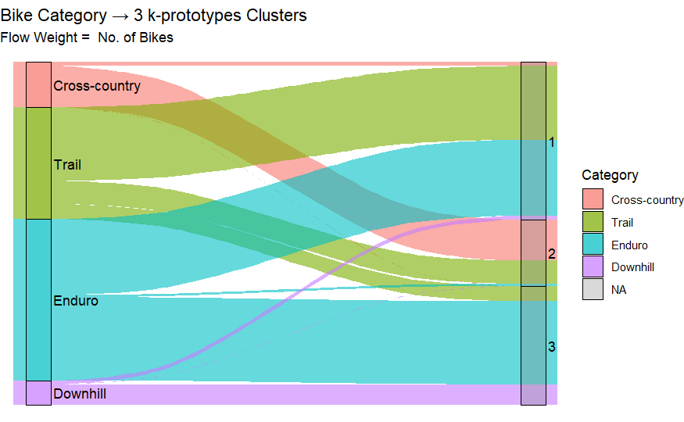
Using the known suspension categories that were determined previously, it is possible to validate the clusters found using k-means and k-prototypes to see if these categories are part of the underlying structure within the dataset. We evaluated results from both clustering models with a contingency matrix (counts and within-cluster proportions) and an Alluvial (Sankey) plot to illustrate category flows across clusters. From these results, the true meaning of the found clusters could be found, and linkages (if there were any) between mountain bike geometries and natural clusters could be determined .
Category | 1 | 2 | 3 | 4 | 5 | 6
C-C | 11 | 10 | 0 | 0 | 0 | 60
Trail | 99 | 21 | 39 | 19 | 5 | 16
Enduro | 60 | 16 | 143 | 43 | 25 | 0
Downhill | 0 | 0 | 20 | 17 | 6 | 0
Contingency Matrix for 6 k-means clusters
Category | 1 | 2 | 3
C-C | 8 | 73 | 0
Trail | 131 | 41 | 27
Enduro | 135 | 4 | 148
Downhill | 7 | 0 | 36
Contingency Matrix for 3 k-prototypes clusters

Discussion

Interpretation of Results
PCA suggests two latent dimensions - slack geometry and rider position. Using these two components the bikes were naturally separated into six clusters from k-means clustering. Cluster 1 was majority Trail with some shorter-suspension Enduro. Cluster 3 was predominantly Enduro. Cluster 4 comprised longer-suspension Enduro with some Downhill. Cluster 6 aligned strongly with Cross Country. Clusters 2 and 5 were mixed. Drawing on common naming conventions, inspection of representative bikes and domain expertise, we label the clusters as follows:
- Trail / light Enduro
- Mixed bag (Enduro or park bikes)
- Enduro
- All Mountain (light Enduro / heavy Trail + Downhill)
- Mixed bag (specialised Enduro)
- Cross Country
Doing this same analysis for the mixed clustering found that Cluster 1 had an even Mixture of Trail and Enduro, Cluster 2 was strongly linked to Cross Country, and Cluster 3 was strongly mixed with Enduro and Downhill, we labelled the clusters as follows:
- Mixed Trail Enduro
- Cross Country
- Mixed Enduro Downhill
A noteworthy outcome from both clustering’s is that a distinct Downhill cluster did not emerge. Despite the media profile of Downhill racing, the underlying geometry appears either relatively rare in the dataset or is represented by bikes modified after purchase toward longer travel, which then blend into the more aggressive Enduro groups.
Enduro also seems like it is too generic of a term and constitutes many different types of bikes. This is particularly seen in the mixed k=3 case, where Enduro bikes seem to be split almost evenly between clusters 1 and 3. The same is true for k-means k=6, where there seems to be an approximate half split to cluster 3 with the other half being spread between the other clusters. This could indicate that there is a subgroup for ‘true’ Enduro bikes, with other clusters indicating that 50% of what is currently classified as Enduro could be considered for other classification.
Finally, it was noted that with the Mixed Bag smaller clusters – there is a higher weighting to e-bikes. We did not consider e-bikes vs analogue bikes (specifically with a separate category for e-bikes) in the design of our research which could be another contributing factor to how our clusters were created.
Clusters themselves were also observed to determine new underlying groupings within the data. 2 new naturally emerging categories were identified after observing the many different configurations found by both different clustering algorithms on the PC scatterplot.
- Negative slack geometry (PC1=-3) centred around (3,0) and neutral rider position
(-2<PC2<2), appeared to form a ‘true Cross-Country’ bike category
- Both positive slack geometry and rider position, the very dense top right region centred around (1,1), appeared to form a ‘mixed Enduro-Trail-Downhill’ category. Bikes in this region could be considered ‘standard’ mountain bikes. This could indicate that the true bikes for these categories are represented by the outliers and are not in this dense region.

Method Limitations & Data Assumptions
PCA captures linear structure along two axes (slack geometry, rider position), so non-linear relationships may be missed. k-means assumes roughly spherical, similarly sized clusters, and it is unlikely our real-world data is represented like this. Also, results are sensitive to pre-processing choices (feature selection and removing bikes that had missing-data). External validity was limited: clusters reflect only a sample of bikes for a period of years and labels were not strictly defined in the data. We assigned labels from assumptions from the suspension variables.
We treated the category labels (Cross Country, Trail, Enduro, Downhill) as guides, not gospel. We assumed the dataset was broadly representative across brands, travel and wheel sizes, but gaps (like boutique DH or women-specific models) could have led to misclustering. We also assumed e-bikes share similar geometry to analogue bikes. Our analysis has hinted the motor, and packaging might alter geometry and therefore our clusters. Finally, model years weren’t analysed (the Model categorical variable) – MTB geometry has shifted over time (longer, lower, slacker), so mixing vintages may blur boundaries and influence the clusters.

Comparison between Clustering Methods
After applying both clustering methods, there were some key similarities and differences that were found, particularly in the inputs and outputs for the methods. In k-means clustering, the PCA data was used to create the clusters. This made for difficult interpretation of the individual clusters (due to having to determine what the loadings for each PC meant realistically) but perfect for cluster visualisation on the 2D plot. In contrast, the k-prototypes clustering, made possible through ClustMixType R package, required raw, unscaled data for its clustering algorithm otherwise the weights could be calculated incorrectly. PCA could not be used as it did not account for the variability described by the categorical variables. This meant that the final clusters were much easier to compare difference between (as abstract assumptions did not need to be made from PCs), however due to the variables supplied, it was still difficult to determine general differences between the clusters. It also made visualisation of the clusters through plots difficult. Interestingly, the decision to plot these k-prototypes clusters against the same PCs as those use in the k-means clustering resulted in mostly interpretable plots (specifically for making generalisations about the clusters).
After clustering, all methods seemed to produce two generic groupings of data. This was determined to be the distinction between cross-country bikes and the non-cross-country bikes. Regardless of the clustering method, the other categories of bikes seemed to have minor distinctions (if any at all) that meant when it came to clustering, they did not generalise into easily distinguishable groups (not until very large values for k). Visually the k-prototypes plots had many overlapping clusters as opposed to the clean groupings seen in k-means. This meant that while it was possible to visually determine an optimal number visually for the k-means method (opposed to what was initially suggested by the elbow plot), instead the elbow plot was the main contributor to deciding the optimal number of clusters for the mixed clustering algorithm.
While visually they were quite different, especially when looking at higher values of k for mixed clustering, both clustering methods did seem to produce ‘similar’ clusters when inspecting centres. This meant that there did seem to be consistent structure within the data that was found using the clustering algorithms.

Extension of Knowledge

Multi-class Support Vector Machine Classification
We also applied Multi-class Support Vector Machine Classification. We did this by using the e1071 package. We created a svm_df that contained only the feature names and split it into a training and testing set. Class imbalance was handled with median-frequency class weights, then grid-searched for cost (C) and gamma with 5-fold cross validation to pick a sensible model. The best cost was determined to be 256 and the best gamma is 0.03125. The accuracy score was 0.779 for our best model. As the corresponding p-value was 2.2e-16, the accuracy score was deemed to be statistically significant, indicating that the accuracy was different to the no information rate (the percentage of instances where the data is missing).
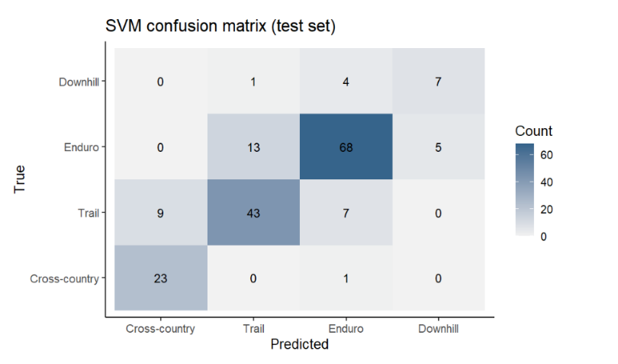
The confusion matrix allowed us to analyse how accurate the model is in predicting correctly across different categories. This was also confirmed numerically from a table of Precision, Recall and F1 scores for each category.
The cross-country bike predictions were the most accurate. The Enduro bikes sometimes (13/86) were misclassified for Trail bikes. The Downhill bikes were often misclassified for Enduro bikes (proportionally this was 4/12 = 1/3 of all observations).
The SVM decision-region plot in PCA space provides a visual indication of where categories overlap.
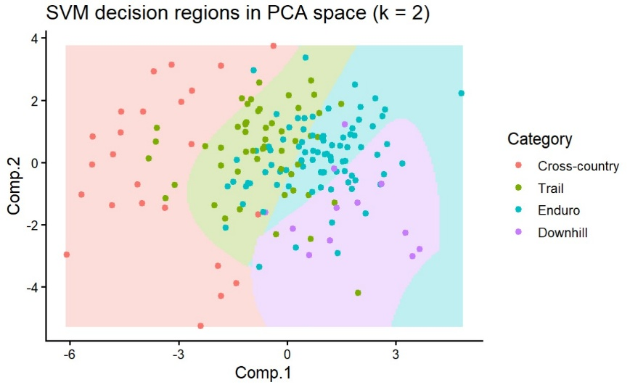

Conclusions
During this project we considered clusters using two different methods, including k-means clustering and k-prototypes from the R package ClustMixType. We also applied Multi-class Support Vector Machine Classification. This was done after applying the appropriate data cleaning and preprocessing steps. PCA was also applied which left us with analysing only two principal components which were determined to represent the slack geometry and rider position respectively.
The elbow plot of the k-means method determined that the optimal k appeared to be k=4 (elbow point). After calculating and viewing the partitioning’s for the different k-means models. The k=3 case had clusters that weren’t elliptical and were too sparse, the k=4 case had clusters that were too close making distinguishing between clusters difficult, and the k=5 case was like the k=6 case but had slightly closer clusters and worse cluster shape. Higher values of k were considered, however even though these clusters technically performed better, they were highly specialised making them both very sparse and badly shaped. The k=6 clusters performed the best under these conditions when compared to the other configurations. This suggests that according to our k-means clustering there are really six mountain bike categories. The ClustMixType package determined that the optimal configuration was for three clusters (k=3). For k=4 one of the previous three clusters split in half, with this extra cluster not contributing enough for its increased complexity. The higher k values resulted in clusters that were too sparse and had overlapping occurrences. Therefore, with this method we concluded that three categories made the most sense as they were the most numerically and visually distinct, while still being somewhat dense.
Using the results from these optimal clustering models and comparing them with the suspension categories, it was found that the industry defined labels were not typically indicative of the natural groupings present within the data. All categories but cross-country failed to generalise into the optimal clusters found by both methods. Alternatively, using the clusters to determine new categories from the best principal components showed that two new categories could be named. These were named True Cross-Country and Standard.
The Multi-class Support Vector Machine Classification created a model from the four categories mentioned. This method aimed to create the best model by predicting the best (cost, gamma) pair for the accuracy of the model. The best SVM model had an accuracy score of 77.9% and was determined to be a strong model with a significant accuracy score. This proves that the original four categories can be a suitable splitting of mount bikes for classification (regardless of the underlying structure within the data found through clustering).
Future research into the clustering of mountain bike geometries could further explore the impact of electric versus non-electric bikes. Within our investigation it was observed that not having this distinction meant that smaller clusters consisted of a seemingly random combination of categories. By exploring e-bikes as a confounding factor, it would be possible to further explore the true natural clusters of mountain bikes through their geometries, which may lead to new discoveries for possible mountain bike categories. Other future research could involve exploration into different clustering techniques (with different distance functions), and a re-examination of which variables should truly be considered for a clustering investigation through consultation with an industry expert.
Overall, our investigation succeeded in determining underlying structure within the mountain bike dataset using clustering algorithms. This confirmed the suspicion that industry labels are not necessarily true definitions of mountain bike frame geometries and instead should be attributed to other aspects of the bikes.

References

Dantas, N. C. D. 2023. “Evaluating clustering.” Medium, October 7, 2023. https://medium.com/@nielsencastelodamascenodantas/evaluating-clustering-f861ee922065.

Foss, Alan H., Marianthi Markatou, and Bodhisattva Ray. 2019. “Distance metrics and clustering methods for mixed-type data.” International Statistical Review 87 (1): 80–109. https://doi.org/10.1111/insr.12274.

Geometry Geeks. n.d. “Understanding bike geometry.” Accessed August 9, 2025. https://geometrygeeks.bike/understanding-bike-geometry/.

Hamina, Syad. 2024. “Data reduction using principal component analysis: Theoretical underpinnings and practical applications in public health.” Journal of Clinical & Medical Education. Advance online publication. https://www.jcmedu.org/jcmedu-articles/data-reduction-using-principal-component-analysis-theoretical-underpinnings-and-practical-applications-in-public-health-105124.html.

Jolliffe, Ian T., and Jorge Cadima. 2016. “Principal component analysis: A review and recent developments.” Philosophical Transactions of the Royal Society A: Mathematical, Physical and Engineering Sciences 374 (2065): 20150202. https://doi.org/10.1098/rsta.2015.0202.

Pandelu, Adithya P. 2024. “Day 23: K Means Clustering — Theory and Implementation.” Medium, November 19, 2024. Accessed August 15, 2025. https://medium.com/@bhatadithya54764118/day-23-k-means-clustering-theory-and-implementation-b171b4f14bce.

Pollard, David. 1981. “Strong consistency of k-means clustering.” The Annals of Statistics 9 (1). https://doi.org/10.1214/aos/1176345339

Prill, Dorian. n.d. dataset-bicycle-geometry [Data set and code]. GitHub. Accessed August 9, 2025. https://github.com/dorianprill/dataset-bicycle-geometry.

Schulberg, Jesse, and Michael Czerwinski. 2022. “Mountain bike categorization analysis.” Datacracy (blog), May 5, 2022. Accessed August 9, 2025https://datacracy.netlify.app/post/2022-05-05-mtb-categorization-analysis/.

Statistics with Jamovi. n.d. “Session 4c: Factor analysis.” Accessed September 11, 2025. https://learnstatswithjamovi.wordpress.com/session-4c-factor-analysis/.

Szepannek, Gábor, and Rainer Aschenbruck. n.d. clustMixType: k-Prototypes clustering for mixed variable type data [R package]. CRAN. Accessed August 16, 2025. https://cran.r-project.org/web/packages/clustMixType/index.html.

Appendices

PCA and Clustering Explanation

PCA
PCA is a statistical method that reduces the dimensionality of data while keeping as much information about the dataset as possible. The process re-expresses variables within a dataset into principal components (PCs), each representing a different weighted combinations of the original variables while remaining uncorrelated with the other PCs. The process starts by determining the variance-covariance matrix ($Σ_{p×p}$) from the original dataset/sample ($X_{n×p}$), where $Σ=\frac{1}{n-1}X^{T}X$. This matrix is then used in eigen-decomposition, where the characteristic equation $ΣV=λV→\left(Σ-λI\right)V=0$ can be solved using the property that $\det\left(Σ-λI\right)=0$. This allows the eigenvalues ($λ_{i}$) and eigenvectors ($v_{i}$) of $Σ$ to be calculated, where $i=1,…,p$.
The eigenvalues calculated from this decomposition represent the variance explained by each PC, $var\left(PC_{i}\right)=λ_{i}$. This implies that the total variance of the original data is $\sum_{i=1}^{p}{λ_{i}}=trace\left(Σ\right)=\sum_{i=1}^{p}{s_{ii}^{2}}$; these $λ^{'}s$ should be ordered from largest to smallest (most to least variance explained). The eigenvectors $v_{i}$, now associating to the ordered $λ's$, can be combined to form the eigenvector matrix $V_{p×p}=\left[v_{1} v_{2}…v_{p}\right]$.
This matrix can be used to construct the PC matrix given by the transformation $A_{n×p}=XV$, where each column of $A$ is a different PC. Each PC is uncorrelated with all other PCs as the eigenvectors of $Σ$ (which is a symmetrical matrix) are orthogonal. In PCA only the first K PC’s are kept so that the total portion of variance explained (PVE) by each PC/eigenvector remains greater than a set threshold of the original total variance, where PVE for $λ_{K}$ is $PVE_{K}=\frac{λ_{K}}{\sum_{i=1}^{p}{λ_{i}}}$. The final reduced PCA matrix can be defined as ${A_{K}}_{n×K}={\left[a_{1} a_{2}…a_{n}\right]}^{T}$, where each $a_{i}$ represents an observation in the reduced dataset.

k-means Clustering
k-means clustering is an unsupervised learning algorithm that partitions each observation of the data into a group, clusters $C_{1},…,C_{k}$, based on their Euclidean distance ($\left\|…\right\|$) from the centroids ($1×K$-dimensional means) of said groups, $μ_{1},…,μ_{k}$. Arbitrary centroids are picked to begin the algorithm, then by computing the within-cluster sum of squares (WCSS) and recursively running this algorithm with updated centroids until the assigned cluster for each point (and by proxy centroids) remains constant, it is possible to compute the optimal clusters for a given dataset. This process can be represented by the function(s):
$$\underset{C_{1},…,C_{k}}{arg min}{\sum_{i=1}^{k}{\sum_{z∈C_{i}}{{\left\|z-μ_{i}\right\|}^{2}}}} \\ where WCSS=\sum_{i=1}^{k}{\sum_{z∈C_{i}}{{\left\|z-μ_{i}\right\|}^{2}}} \\ and {\left\|z_{i}-μ_{k}\right\|}^{2}=d(z_{i},μ_{k})=\sum_{j=1}^{K}{{\left(z_{ij}-μ_{kj}\right)}^{2}}$$This algorithm attempts to find the clusters (and centroids) that will minimise the total distance of the data points from their assigned cluster’s centroid (minimise WCSS). The optimal number of clusters (k) is typically decided by both domain knowledge (Schulberg & Czerwinski, 2022) and diagnostic methods such as the Elbow and Silhouette methods.

R Code

Bike Geometry PCA & Clustering
Saf, Tim & Liz
2025-09-11

MTB Frame Geometry Code
by:
Saf Flatters, 21827361
Timothy Bolt, 21493652
Lizanne van Nieuwenhuizen, 21297786

Packages
#Install and load packages chunk
library(ggplot2)
library(dplyr)
##
## Attaching package: 'dplyr'
## The following objects are masked from 'package:stats':
##
## filter, lag
## The following objects are masked from 'package:base':
##
## intersect, setdiff, setequal, union
library(tidyr)
library(patchwork)
library(DataExplorer)
library(MVN)
library(corrplot)
## corrplot 0.95 loaded
library(psych)
##
## Attaching package: 'psych'
## The following object is masked from 'package:MVN':
##
## mardia
## The following objects are masked from 'package:ggplot2':
##
## %+%, alpha
library(ggbiplot)
##
## Attaching package: 'ggbiplot'
## The following object is masked from 'package:psych':
##
## reflect
library(grDevices)
library(devtools)
## Loading required package: usethis
library(factoextra)
## Welcome! Want to learn more? See two factoextra-related books at https://goo.gl/ve3WBa
library(gridExtra)
##
## Attaching package: 'gridExtra'
## The following object is masked from 'package:dplyr':
##
## combine
library(clustMixType)
library(cluster)
library(ggalluvial)
# library(plotly) # for 3d plot, not used rn

Data

Import
#Import data
allbikegeo <- read.csv("Data/geometrics.mtb-news.de.csv", sep = ";", stringsAsFactors = FALSE)

Data Cleaning

Dataframe Prep
Cleaned dataframe with numeric-only data and without Year and Suspension: mtbgeo[, geo_vars]
Cleaned dataframe with all numeric-only data: mtbgeo[, num_vars]
Cleaned dataframe with mixed data: mtbgeo
#Filter to Mountain bikes only
mtbgeo_only <- subset(allbikegeo, Category == "Mountain")
#Filter to remove 26" wheels
mtbgeo_only <- subset(mtbgeo_only, !grepl("26", Wheel.Size))
#Convert 0 Year to NA (for later removal)
mtbgeo_only$Year <- as.integer(mtbgeo_only$Year)
mtbgeo_only$Year[mtbgeo_only$Year == 0] <- NA
#Replace NA for rear suspension with 0 (assume hardtail)
mtbgeo_only$Suspension.Travel..rear. <- as.numeric(mtbgeo_only$Suspension.Travel..rear.)
mtbgeo_only$Suspension.Travel..rear.[is.na(mtbgeo_only$Suspension.Travel..rear.)] <- 0
#Remove rows with NA in 'Suspension.Travel..front.'
mtbgeo_only$Suspension.Travel..front. <- as.numeric(mtbgeo_only$Suspension.Travel..front.)
mtbgeo_only <- mtbgeo_only[!is.na(mtbgeo_only$Suspension.Travel..front.), ]
#Drop columns with too many missing values (> 1000)
keep_cols <- colSums(is.na(mtbgeo_only)) <= 1000
mtbgeo_reduced <- mtbgeo_only[, keep_cols]
#remove unneeded columns
mtbgeo_reduced <- mtbgeo_reduced[, !(names(mtbgeo_reduced) %in% c("Frame.Config", "URL", "Category"))]
#Keep only Medium-sized bikes to allow fair comparison of geometry
mtbgeo_medium <- mtbgeo_reduced[mtbgeo_reduced$Frame.Size %in% c("M", "Medium"), ]
#remove all rows that have any NA's in numeric/integer columns
num_cols <- sapply(mtbgeo_medium, function(x) is.numeric(x) || is.integer(x))
vars_to_check <- names(mtbgeo_medium)[num_cols]
mtbgeo_clean <- mtbgeo_medium[complete.cases(mtbgeo_medium[, vars_to_check]),]
#rename dataframe and check
mtbgeo <- mtbgeo_clean
# str(mtbgeo)
# anyNA(mtbgeo)
#Create numeric only dataframe
num_vars <- sapply(mtbgeo, is.numeric)
# str(mtbgeo[, num_vars])
#Create numeric only without suspension and Year vars dataframe
drop_vars <- c("Year", "Suspension.Travel..rear.", "Suspension.Travel..front.")
geo_vars <- sapply(mtbgeo, is.numeric) & !(names(mtbgeo) %in% drop_vars)
str(mtbgeo[, geo_vars])
## 'data.frame': 616 obs. of 10 variables:
## $ Reach : num 454 450 450 440 433 440 440 450 435 427 ...
## $ Stack : num 624 613 613 624 599 603 603 603 622 628 ...
## $ STR : num 1.37 1.36 1.36 1.42 1.38 ...
## $ Head.Tube.Angle : num 65 64 63.5 64 65.4 65 65 64 66.5 66 ...
## $ Seat.Tube.Angle.Effective: num 75.5 76.5 76.5 75 75 75 75 75.7 74 75 ...
## $ Head.Tube.Length : num 90 110 110 110 110 110 110 110 130 110 ...
## $ Seat.Tube.Length : num 425 435 435 430 440 420 420 420 435 440 ...
## $ Chainstay.Length : num 435 428 441 435 428 ...
## $ Wheelbase : num 1197 1214 1214 1222 1181 ...
## $ Bottom.Bracket.Offset : num 60 9 9 30 9 9 9 9 20 28 ...

Standardisation
mtbgeo_zscores <- mtbgeo #make copy
mtbgeo_zscores[, geo_vars] <- scale(mtbgeo_zscores[, geo_vars]) #standardise geo_vars
str(mtbgeo_zscores)
## 'data.frame': 616 obs. of 18 variables:
## $ Brand : chr "Alchemy" "Alutech" "Alutech" "Alutech" ...
## $ Model : chr "Argos" "CNC E-Fanes" "eFanes 29/275 Comp" "Fanes 29" ...
## $ Year : int 2022 2021 2022 2022 2015 2019 2019 2022 2015 2016 ...
## $ Motorized : chr "false" "true" "true" "false" ...
## $ Frame.Size : chr "M" "M" "M" "M" ...
## $ Wheel.Size : chr "29″" "Mullet 29/27,5" "Mullet 29/27,5" "29″" ...
## $ Reach : num 0.215 0.0668 0.0668 -0.3037 -0.5631 ...
## $ Stack : num 0.327 -0.434 -0.434 0.327 -1.402 ...
## $ STR : num -0.063484 -0.081367 -0.081367 0.000477 -0.050435 ...
## $ Head.Tube.Angle : num -0.152 -0.81 -1.139 -0.81 0.111 ...
## $ Seat.Tube.Angle.Effective: num -0.282 0.271 0.271 -0.559 -0.559 ...
## $ Head.Tube.Length : num -0.52666 0.00715 0.00715 0.00715 0.00715 ...
## $ Seat.Tube.Length : num 0.21 0.861 0.861 0.535 1.186 ...
## $ Chainstay.Length : num -0.5151 -1.1475 0.0687 -0.5151 -1.1475 ...
## $ Wheelbase : num -0.1953 0.0833 0.0833 0.2144 -0.4576 ...
## $ Bottom.Bracket.Offset : num 1.911 -1.096 -1.096 0.142 -1.096 ...
## $ Suspension.Travel..rear. : num 0 170 170 170 170 170 170 170 130 150 ...
## $ Suspension.Travel..front.: num 140 170 170 170 170 170 170 170 150 160 ...

Category Psuedo-labels (Y)
# make y label groups for validation ("Cross-country", "Trail", "Enduro", "Downhill")
mtbgeo_groups <- mtbgeo %>%
mutate(
Category = case_when(
# Downhill: both ends ≥ 180 (must have rear)
!is.na(Suspension.Travel..rear.) &
Suspension.Travel..front. >= 180 & Suspension.Travel..rear. >= 180 ~ "Downhill",
# Enduro: rear 150–180 AND front 140–190 (must have rear)
!is.na(Suspension.Travel..rear.) &
Suspension.Travel..rear. >= 145 & Suspension.Travel..rear. <= 180 &
Suspension.Travel..front. >= 140 & Suspension.Travel..front. <= 190 ~ "Enduro",
# Cross-country: front 100–120 AND (no rear OR rear ≤ 120)
Suspension.Travel..front. >= 100 & Suspension.Travel..front. <= 120 &
(is.na(Suspension.Travel..rear.) | Suspension.Travel..rear. <= 130) ~ "Cross-country",
# Trail: front 121–160 AND rear ≤ 150 (must have rear)
!is.na(Suspension.Travel..rear.) &
Suspension.Travel..front. >= 121 & Suspension.Travel..front. <= 160 &
Suspension.Travel..rear. <= 150 ~ "Trail",
TRUE ~ "Other"
)
)
# order
mtbgeo_groups$Category <- factor(mtbgeo_groups$Category, levels = c("Cross-country", "Trail", "Enduro", "Downhill"))
# Count bikes in each group
mtbgeo_groups %>%
count(Category)
## Category n
## 1 Cross-country 83
## 2 Trail 202
## 3 Enduro 288
## 4 Downhill 43
# View(mtbgeo_groups[mtbgeo_groups$Category == "Other", ])
# Count bikes per category
cat_counts <- mtbgeo_groups %>%
count(Category)
pal_geo <- c("Downhill"="purple",
"Enduro"="mediumturquoise",
"Trail"="yellowgreen",
"Cross-country"="#F8766D")
# Plot number bikes per category
ggplot(cat_counts, aes(x = Category, y = n, fill = Category)) +
geom_col(width = 0.7) +
geom_text(aes(label = n), vjust = -0.4, size = 4) +
scale_fill_manual(values = pal_geo, guide = "none") +
labs(
title = "Number of Bikes per Category",
x = "Category",
y = "Count of Bikes"
) +
theme_classic(base_size = 13) +
theme(
legend.position = "none",
plot.title = element_text(face = "bold", hjust = 0.5)
)
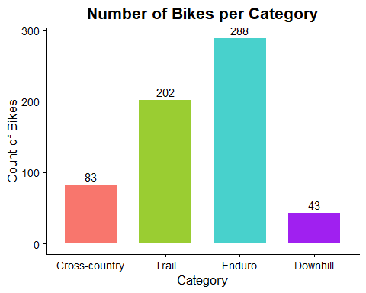

Exploration & Assumption Checks

Outliers
Due to the data being datascraped from the internet, we suspected it may have outliers that aren’t true outliers but more like data entry mistakes.
outlier_rows <- apply(abs(mtbgeo_zscores[, geo_vars]), 1, max) > 7 # Flag rows where any geometry z-score exceeds our threshold
print(mtbgeo[outlier_rows, ]) # View the outliers (without standardised values)
## Brand Model Year Motorized Frame.Size Wheel.Size
## 2216 Giant Reign Advanced Pro 0 2021 false M 29″
## 2600 Intense Sniper XC 2022 false M 29″
## 4493 Rocky Mountain Instinct Powerplay 2022 true M 29″
## 4494 Rocky Mountain Instinct Powerplay 2022 true M 29″
## 5239 Scott Spark 2022 false M 29″
## Reach Stack STR Head.Tube.Angle Seat.Tube.Angle.Effective
## 2216 451.0 622.0 1.379157 64.6 76.4
## 2600 44.5 575.0 12.921348 67.5 74.0
## 4493 45.0 620.0 13.777778 64.7 75.7
## 4494 456.0 518.0 1.135965 65.0 77.0
## 5239 440.0 607.5 1.380682 65.8 75.9
## Head.Tube.Length Seat.Tube.Length Chainstay.Length Wheelbase
## 2216 1000 431 439.0 1220
## 2600 95 437 439.0 1152
## 4493 100 420 437.0 1225
## 4494 100 420 436.0 1224
## 5239 90 440 437.5 1
## Bottom.Bracket.Offset Suspension.Travel..rear. Suspension.Travel..front.
## 2216 27.0 146 170
## 2600 38.0 100 100
## 4493 36.0 140 150
## 4494 32.0 140 150
## 5239 43.5 120 130
# View((mtbgeo[outlier_rows, ]))
# remove above observations
mtbgeo <- mtbgeo[!outlier_rows, ]
mtbgeo_zscores <- mtbgeo_zscores[!outlier_rows, ]
mtbgeo_groups <- mtbgeo_groups[!outlier_rows, ]
nrow(mtbgeo)
## [1] 611
nrow(mtbgeo_groups)
## [1] 611
Matrix_mtbgeo_z <- as.matrix(mtbgeo_zscores[, geo_vars])
# mvn(Matrix_mtbgeo_z, mvn_test = "royston", univariate_test = "AD") #or mvn_test = "hz" or "royston" or
multivariate_diagnostic_plot(Matrix_mtbgeo_z)
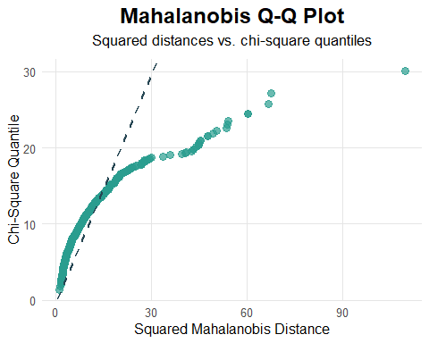
univariate_diagnostic_plot(Matrix_mtbgeo_z, type = "boxplot")
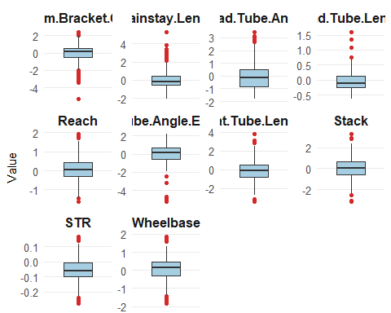
# Check for outliers shown with mahalanobis and remove outlier (2022 Lapace Prorace)
md <- mahalanobis(Matrix_mtbgeo_z,
center = colMeans(Matrix_mtbgeo_z),
cov = cov(Matrix_mtbgeo_z))
sqrt(max(md))
## [1] 10.45501
maxmala <- which.max(md)
mtbgeo[which.max(md), ]
## Brand Model Year Motorized Frame.Size Wheel.Size Reach Stack STR
## 2700 Lapierre Prorace 2022 false M 29″ 435 597 1.372414
## Head.Tube.Angle Seat.Tube.Angle.Effective Head.Tube.Length
## 2700 68 74 90
## Seat.Tube.Length Chainstay.Length Wheelbase Bottom.Bracket.Offset
## 2700 430 420 1114 -62
## Suspension.Travel..rear. Suspension.Travel..front.
## 2700 0 100
mtbgeo <- mtbgeo[-maxmala, ] # remove above observation
mtbgeo_zscores <- mtbgeo_zscores[-maxmala, ] # remove above observation
mtbgeo_groups <- mtbgeo_groups[-maxmala, ] # remove above observation
# column means
(colMeans(mtbgeo[, geo_vars]))
## Reach Stack STR
## 449.537344 619.559426 1.379396
## Head.Tube.Angle Seat.Tube.Angle.Effective Head.Tube.Length
## 65.224869 76.014672 108.393443
## Seat.Tube.Length Chainstay.Length Wheelbase
## 421.699180 440.348885 1211.078131
## Bottom.Bracket.Offset
## 27.677000
# (View(cov(mtbgeo[, geo_vars])))
This was moved to after outliers were removed as it wasn’t a good representation of the data
# Check distributions of each variable
vars <- c(names(mtbgeo)[geo_vars],
"Suspension.Travel..rear.",
"Suspension.Travel..front.")
df_long <- mtbgeo[, vars] |>
pivot_longer(everything(), names_to = "var", values_to = "val") # Long format for faceting
n_geo <- length(geo_vars)
pal_geo <- grDevices::hcl.colors(n_geo, palette = "viridis")
pal_susp <- grDevices::hcl.colors(2, palette = "reds")
pal <- c(pal_geo, pal_susp)
ggplot(df_long, aes(x = val, fill = var)) +
geom_density(alpha = 0.7) +
facet_wrap(~ var, scales = "free", ncol = 3) +
scale_fill_manual(values = pal, guide = "none") +
labs(title = "Distribution of Geometry Variables + Suspension",
x = "Geometry Variables",
y = "Density") +
theme_classic() +
theme(
plot.title = element_text(hjust = 0.5, color = "slateblue4", size = 16),
axis.title.x = element_text(size = 14),
axis.title.y = element_text(size = 14)
)
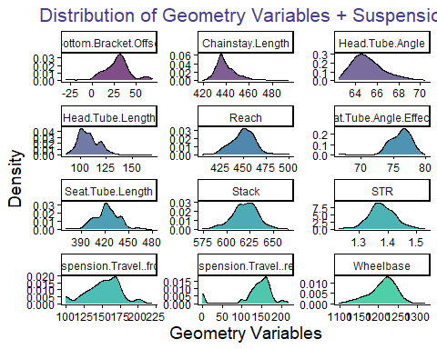

Correlation
# Correlation matrix
Matrix_mtbgeo <- as.matrix(mtbgeo[, geo_vars])
round(cor(Matrix_mtbgeo), 4)
## Reach Stack STR Head.Tube.Angle
## Reach 1.0000 0.1781 -0.7803 -0.3836
## Stack 0.1781 1.0000 0.4747 -0.4575
## STR -0.7803 0.4747 1.0000 0.0599
## Head.Tube.Angle -0.3836 -0.4575 0.0599 1.0000
## Seat.Tube.Angle.Effective 0.5225 0.1730 -0.3626 -0.3424
## Head.Tube.Length 0.0295 0.3485 0.2032 -0.1321
## Seat.Tube.Length -0.0700 -0.1259 -0.0077 0.3777
## Chainstay.Length -0.0141 0.2900 0.2040 -0.0724
## Wheelbase 0.6275 0.5548 -0.2094 -0.8367
## Bottom.Bracket.Offset -0.1946 -0.0815 0.1264 0.4880
## Seat.Tube.Angle.Effective Head.Tube.Length
## Reach 0.5225 0.0295
## Stack 0.1730 0.3485
## STR -0.3626 0.2032
## Head.Tube.Angle -0.3424 -0.1321
## Seat.Tube.Angle.Effective 1.0000 -0.0273
## Head.Tube.Length -0.0273 1.0000
## Seat.Tube.Length -0.1602 0.0987
## Chainstay.Length -0.0613 0.2731
## Wheelbase 0.3973 0.2782
## Bottom.Bracket.Offset -0.1132 -0.3143
## Seat.Tube.Length Chainstay.Length Wheelbase
## Reach -0.0700 -0.0141 0.6275
## Stack -0.1259 0.2900 0.5548
## STR -0.0077 0.2040 -0.2094
## Head.Tube.Angle 0.3777 -0.0724 -0.8367
## Seat.Tube.Angle.Effective -0.1602 -0.0613 0.3973
## Head.Tube.Length 0.0987 0.2731 0.2782
## Seat.Tube.Length 1.0000 0.1254 -0.2020
## Chainstay.Length 0.1254 1.0000 0.4124
## Wheelbase -0.2020 0.4124 1.0000
## Bottom.Bracket.Offset 0.0637 -0.2267 -0.5601
## Bottom.Bracket.Offset
## Reach -0.1946
## Stack -0.0815
## STR 0.1264
## Head.Tube.Angle 0.4880
## Seat.Tube.Angle.Effective -0.1132
## Head.Tube.Length -0.3143
## Seat.Tube.Length 0.0637
## Chainstay.Length -0.2267
## Wheelbase -0.5601
## Bottom.Bracket.Offset 1.0000
# Correlation plot
corrplot(cor(Matrix_mtbgeo), method = "color", type = "upper",
tl.col = "black", tl.srt = 45, addCoef.col = "black",
number.cex = 0.6) # correlation heatmap
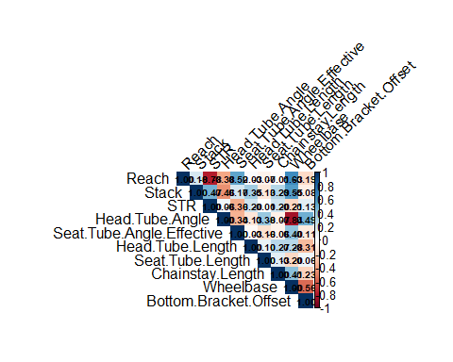
# Use MSA to check suitable correlations for PCA (see report PCA references)
cortest.bartlett(cor(mtbgeo[, geo_vars]), n = nrow(mtbgeo[, geo_vars]))
## $chisq
## [1] 6961.725
##
## $p.value
## [1] 0
##
## $df
## [1] 45
KMO(cor(mtbgeo[, geo_vars]))
## Kaiser-Meyer-Olkin factor adequacy
## Call: KMO(r = cor(mtbgeo[, geo_vars]))
## Overall MSA = 0.45
## MSA for each item =
## Reach Stack STR
## 0.40 0.33 0.34
## Head.Tube.Angle Seat.Tube.Angle.Effective Head.Tube.Length
## 0.49 0.96 0.72
## Seat.Tube.Length Chainstay.Length Wheelbase
## 0.75 0.24 0.54
## Bottom.Bracket.Offset
## 0.54
# remove weak MSA variables < 0.4
weak_vars <- c("Chainstay.Length", "STR", "Stack")
# check correlation and MSA of strong MSA variables < 0.48
strong_vars <- sapply(mtbgeo, is.numeric) &
!(names(mtbgeo) %in% c("Year",
"Suspension.Travel..rear.",
"Suspension.Travel..front.",
weak_vars))
KMO(cor(mtbgeo[, strong_vars]))
## Kaiser-Meyer-Olkin factor adequacy
## Call: KMO(r = cor(mtbgeo[, strong_vars]))
## Overall MSA = 0.61
## MSA for each item =
## Reach Head.Tube.Angle Seat.Tube.Angle.Effective
## 0.54 0.59 0.78
## Head.Tube.Length Seat.Tube.Length Wheelbase
## 0.48 0.60 0.58
## Bottom.Bracket.Offset
## 0.83
Matrix_mtbstrong <- as.matrix(mtbgeo[, strong_vars])
corrplot(cor(Matrix_mtbstrong), method = "color", type = "upper",
tl.col = "black", tl.srt = 45, addCoef.col = "black",
number.cex = 0.6) # correlation heatmap
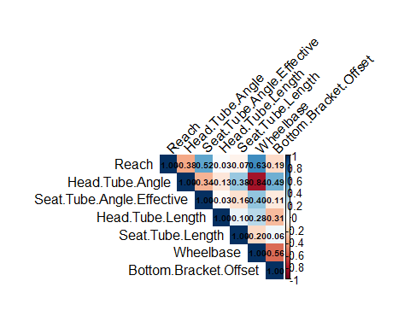

Linearity
# outputs a PDF to file of scatterplots of all combinations of variables to check linearity
vars <- names(mtbgeo)[strong_vars]
pdf("scatterpairs_all.pdf", width = 6, height = 5)
# loop over all pairs
cmb <- combn(vars, 2, simplify = FALSE)
for (xy in cmb) {
x <- xy[1]; y <- xy[2]
plot(mtbgeo[[x]], mtbgeo[[y]],
xlab = x, ylab = y, pch = 20, col = "grey40",
main = paste(y, "vs", x))
abline(lm(mtbgeo[[y]] ~ mtbgeo[[x]]), lty = 2, col = "black") # visual linear fit
}
dev.off()
## png
## 2

Principal Component Analysis
# Perform PCA:
pca <- princomp(mtbgeo[, strong_vars], #PCA
cor = TRUE)
pca$loadings
##
## Loadings:
## Comp.1 Comp.2 Comp.3 Comp.4 Comp.5 Comp.6 Comp.7
## Reach 0.397 0.269 0.458 0.433 0.534 0.296
## Head.Tube.Angle -0.496 0.281 -0.170 -0.149 0.558 -0.559
## Seat.Tube.Angle.Effective 0.331 0.419 0.358 -0.335 -0.656 -0.207
## Head.Tube.Length 0.157 -0.657 0.114 -0.716 0.105
## Seat.Tube.Length -0.193 -0.342 0.743 0.404 -0.353
## Wheelbase 0.542 0.126 0.272 -0.180 -0.759
## Bottom.Bracket.Offset -0.362 0.442 0.133 -0.409 0.529 -0.451
##
## Comp.1 Comp.2 Comp.3 Comp.4 Comp.5 Comp.6 Comp.7
## SS loadings 1.000 1.000 1.000 1.000 1.000 1.000 1.000
## Proportion Var 0.143 0.143 0.143 0.143 0.143 0.143 0.143
## Cumulative Var 0.143 0.286 0.429 0.571 0.714 0.857 1.000
summary(pca) # Std. dev, Proportion of Var, Cumulative Var
## Importance of components:
## Comp.1 Comp.2 Comp.3 Comp.4 Comp.5
## Standard deviation 1.7305214 1.1425085 1.0211798 0.81926231 0.71028431
## Proportion of Variance 0.4278149 0.1864751 0.1489726 0.09588439 0.07207197
## Cumulative Proportion 0.4278149 0.6142900 0.7632626 0.85914697 0.93121894
## Comp.6 Comp.7
## Standard deviation 0.62983170 0.29116905
## Proportion of Variance 0.05666971 0.01211134
## Cumulative Proportion 0.98788866 1.00000000
eigvals <- pca$sdev^2 # eigenvalues λ_i
eigvals
## Comp.1 Comp.2 Comp.3 Comp.4 Comp.5 Comp.6 Comp.7
## 2.99470429 1.30532566 1.04280813 0.67119074 0.50450380 0.39668797 0.08477941

Component Selection
# Select n components
pve <- eigvals / sum(eigvals) # proportion of total variance
round(cbind(Eigenvalue = eigvals,
Proportion = pve,
CumProp = cumsum(pve)), 3)
## Eigenvalue Proportion CumProp
## Comp.1 2.995 0.428 0.428
## Comp.2 1.305 0.186 0.614
## Comp.3 1.043 0.149 0.763
## Comp.4 0.671 0.096 0.859
## Comp.5 0.505 0.072 0.931
## Comp.6 0.397 0.057 0.988
## Comp.7 0.085 0.012 1.000
plot(pca, type = "l", main = "Scree Plot of Principal Components")
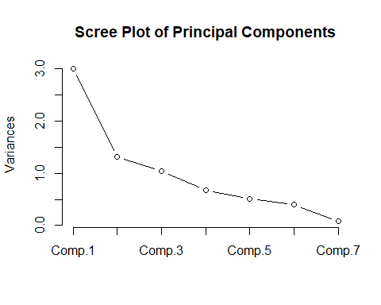
## Bar scree (optional) + Kaiser line at 1 (on correlation, λ=1 rule)
barplot(eigvals, names.arg = paste0("PC", seq_along(eigvals)),
main = "Eigenvalues (Bar Scree)", ylab = "Eigenvalue")
abline(h = 1, col = 2, lty = 2)
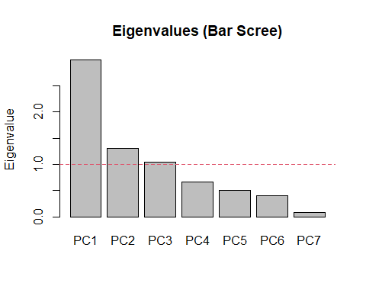
summary(pca)
## Importance of components:
## Comp.1 Comp.2 Comp.3 Comp.4 Comp.5
## Standard deviation 1.7305214 1.1425085 1.0211798 0.81926231 0.71028431
## Proportion of Variance 0.4278149 0.1864751 0.1489726 0.09588439 0.07207197
## Cumulative Proportion 0.4278149 0.6142900 0.7632626 0.85914697 0.93121894
## Comp.6 Comp.7
## Standard deviation 0.62983170 0.29116905
## Proportion of Variance 0.05666971 0.01211134
## Cumulative Proportion 0.98788866 1.00000000
loadings <- pca$loadings
print(loadings)
##
## Loadings:
## Comp.1 Comp.2 Comp.3 Comp.4 Comp.5 Comp.6 Comp.7
## Reach 0.397 0.269 0.458 0.433 0.534 0.296
## Head.Tube.Angle -0.496 0.281 -0.170 -0.149 0.558 -0.559
## Seat.Tube.Angle.Effective 0.331 0.419 0.358 -0.335 -0.656 -0.207
## Head.Tube.Length 0.157 -0.657 0.114 -0.716 0.105
## Seat.Tube.Length -0.193 -0.342 0.743 0.404 -0.353
## Wheelbase 0.542 0.126 0.272 -0.180 -0.759
## Bottom.Bracket.Offset -0.362 0.442 0.133 -0.409 0.529 -0.451
##
## Comp.1 Comp.2 Comp.3 Comp.4 Comp.5 Comp.6 Comp.7
## SS loadings 1.000 1.000 1.000 1.000 1.000 1.000 1.000
## Proportion Var 0.143 0.143 0.143 0.143 0.143 0.143 0.143
## Cumulative Var 0.143 0.286 0.429 0.571 0.714 0.857 1.000
K <- which(cumsum(pve) >= 0.80)[1] # first K with ≥80% cumulative variance
K
## Comp.4
## 4
# pca scores for each bike
id_cols <- c("Brand", "Model", "Year")
scores_df <- cbind(
mtbgeo[, intersect(id_cols, names(mtbgeo)), drop = FALSE],
as.data.frame(pca$scores)
)
head(scores_df)
## Brand Model Year Comp.1 Comp.2 Comp.3 Comp.4
## 54 Alchemy Argos 2022 -1.12220658 1.9271429 0.21213758 0.6055906
## 65 Alutech CNC E-Fanes 2021 0.80899997 -0.7787171 0.39605044 0.7578285
## 68 Alutech eFanes 29/275 Comp 2022 0.97231320 -0.7789735 0.30337402 0.8138334
## 81 Alutech Fanes 29 2022 -0.02323165 -0.6662922 -0.29358611 0.4141721
## 85 Alutech Fanes 5.0 2015 -0.95385396 -1.4810823 0.02610024 0.8944237
## 90 Alutech Fanes 6.0 2019 -0.21179039 -0.9291561 -0.77881421 0.4530563
## Comp.5 Comp.6 Comp.7
## 54 1.1222645 -0.7246885 0.16334824
## 65 -0.6102684 -0.3017038 0.55459387
## 68 -0.5611432 -0.4853208 0.73863923
## 81 0.3562469 -1.0043172 0.09158096
## 85 -0.9762645 -0.2141265 0.42597192
## 90 -0.6257484 0.3098214 0.39760815

PCA Biplot
# Biplot using pseudo-labelled colours with 50% probability ellipses, showing variable orthogonality
mtbgeo_groups$Category <- factor(mtbgeo_groups$Category, levels = c("Cross-country", "Trail", "Enduro", "Downhill"))
ggbiplot(pca,
obs.scale = 2,
var.scale = 2,
point.size = 1.2,
varname.adjust = 2,
groups = mtbgeo_groups$Category,
ellipse = TRUE,
ellipse.linewidth = 0.2,
circle = FALSE,
ellipse.prob = .5) +
theme_classic() +
labs(title = "PCA biplot with bike categories (50% probability ellipses)") +
theme(legend.direction = 'horizontal',
legend.position = 'top')
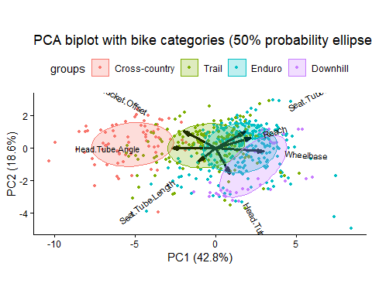

Clustering (K means)

Choosing k
# put the pca scores into a dataframe
clustering_data <- as.data.frame(pca$scores)
colnames(clustering_data) <- c("PC1", "PC2", "PC3", "PC4")
clustering_sub2 <- clustering_data[ , 1:2]
clustering_sub3 <- clustering_data[ , 1:3]
clustering_sub4 <- clustering_data[ , 1:4]
# do some sort of test to figure out what k should be
set.seed(123)
( sub2_p1 <- fviz_nbclust(clustering_sub2, kmeans, method = "wss") )
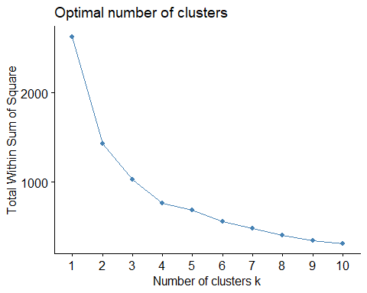
( sub2_p2 <- fviz_nbclust(clustering_sub2, kmeans, method = "silhouette") )
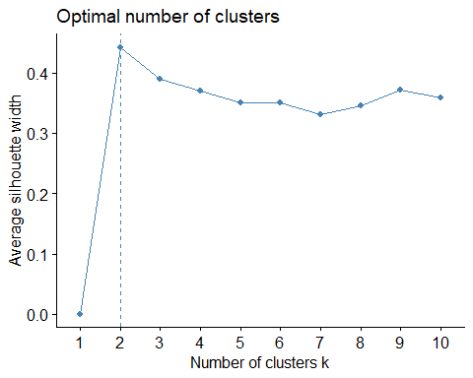
( sub2_p3 <- fviz_nbclust(clustering_sub2, kmeans, method = "gap_stat") )
## Warning: `aes_string()` was deprecated in ggplot2 3.0.0.
## ℹ Please use tidy evaluation idioms with `aes()`.
## ℹ See also `vignette("ggplot2-in-packages")` for more information.
## ℹ The deprecated feature was likely used in the factoextra package.
## Please report the issue at <https://github.com/kassambara/factoextra/issues>.
## This warning is displayed once every 8 hours.
## Call `lifecycle::last_lifecycle_warnings()` to see where this warning was
## generated.
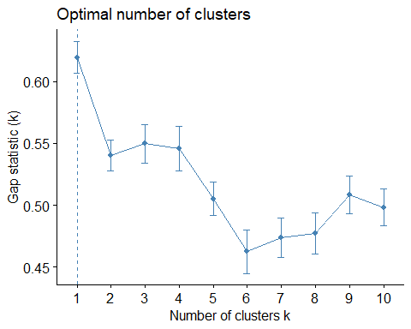
# fviz_nbclust(clustering_sub3, kmeans, method = "wss")
# fviz_nbclust(clustering_sub4, kmeans, method = "wss")
grid.arrange(grobs = c(sub2_p1, sub2_p2), ncol=2)
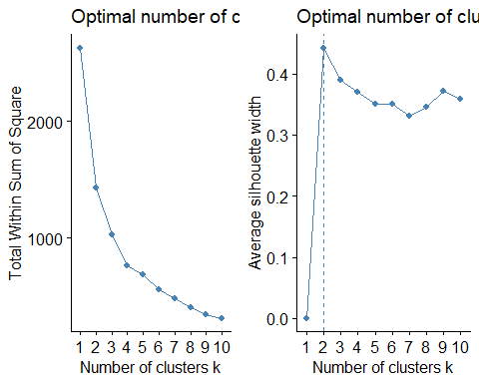
#Anything from 3 to 6 clusters is optimal. I will do clustering and print plots with 3, 4, 5 and 6 clusters and then see which one looks best.

Clusters
# Check to see what data looks like before being clustered, guess what points would realistically be grouped together
plot(clustering_sub2$PC1, clustering_sub2$PC2)
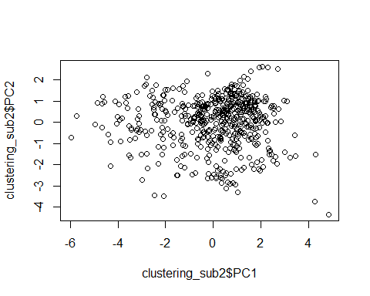
obs_kclusts <- function(k, clust_data) {
kmTest <- kmeans(clust_data, centers=k, nstart = 20)
ratio <- kmTest$betweenss/kmTest$totss
print(paste("ratio for",k,"clusters:", ratio))
return(kmTest)
}
print_kclusts <- function(kmTest, clust_data) {
plot_k <- fviz_cluster(kmTest, geom = "point", data = clust_data, choose.vars = c("PC1", "PC2")) +
ggtitle(paste("k =", k)) + theme_minimal()
plot_k
}
clustering_data <- clustering_sub2
n <- 7 # max number of clusters to test
results <- list()
for (k in 2:n) {
results[[paste0("k", k)]] <- obs_kclusts(k, clustering_data)
}
## [1] "ratio for 2 clusters: 0.455072654186252"
## [1] "ratio for 3 clusters: 0.609928521715944"
## [1] "ratio for 4 clusters: 0.708715247003452"
## [1] "ratio for 5 clusters: 0.757696117650921"
## [1] "ratio for 6 clusters: 0.79151910283358"
## [1] "ratio for 7 clusters: 0.82100429539077"
lapply(results, print_kclusts, clustering_data)
## $k2
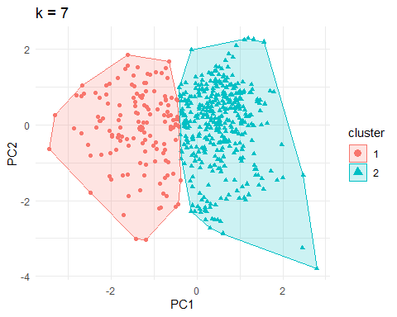
##
## $k3
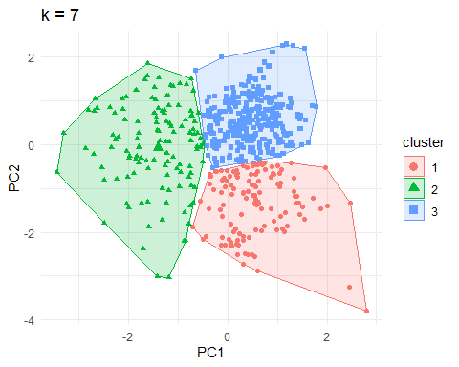
##
## $k4
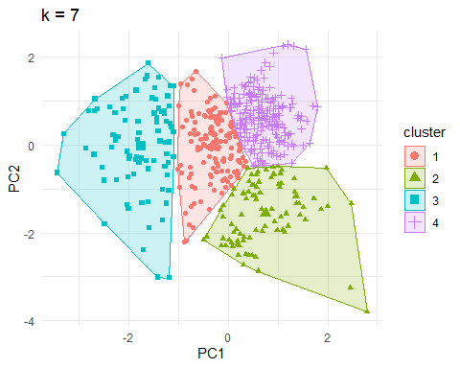
##
## $k5
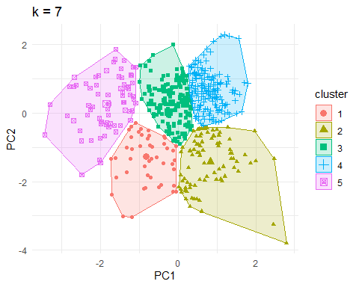
##
## $k6
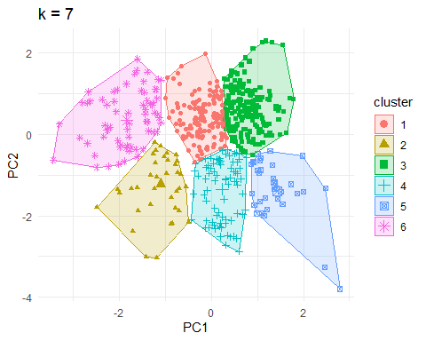
##
## $k7
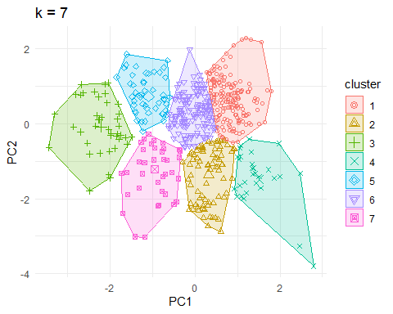
plots <- list()
for (k in 2:n) {
kmTest <- kmeans(clustering_sub2, centers = k, nstart = 20)
plots[[paste0("k", k)]] <- fviz_cluster(kmTest, geom = "point", data = clustering_sub2, choose.vars = c("PC1", "PC2")) + ggtitle(paste("k =", k))
}
ktest <- kmeans(clustering_sub2, centers = 2, nstart = 20)
fviz_cluster(ktest, geom = "point", data = clustering_sub2, choose.vars = c("PC1", "PC2")) + ggtitle("k = 3") + theme_classic()
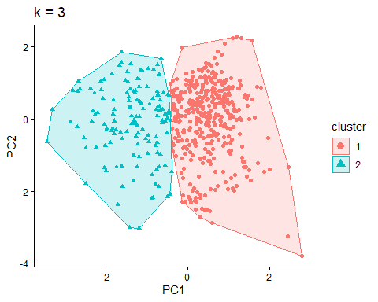
grid.arrange(grobs = plots, ncol = 3)
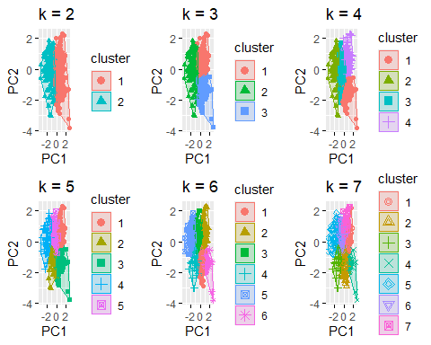

Sankey and Confusion charts
bike_confusion_table <- function(data, cluster_data) {
data_clone <- data
data_clone$cluster <- factor(cluster_data$cluster)
data_clone$Category <- factor(mtbgeo_groups$Category, levels = c("Cross-country", "Trail", "Enduro", "Downhill"))
# confusion-style table
tab <- table(Cluster = data_clone$cluster, Category = data_clone$Category)
prop.table(tab, 1) # row %: composition of each cluster
return(tab)
}
bike_sankey <- function(table, plot_title) {
df_alluv <- as.data.frame(table) %>% as_tibble()
ggplot(df_alluv, aes(axis1 = Category, axis2 = Cluster, y = Freq)) +
geom_alluvium(aes(fill = Category), width = 0.1, alpha = 0.6) +
geom_stratum(aes(fill = Category), width = 0.05, alpha=0.3) +
# scale_fill_brewer(palette = "Dark2", name = "Category") +
geom_text(stat = "stratum", aes(label = after_stat(stratum)), hjust = 0, nudge_x = 0.03) +
labs(title = plot_title, y = "", subtitle = "Flow Weight = No. of Bikes") +
theme_void() + theme(axis.text.y = element_blank(), axis.text.x = element_blank())
}
(table1 <- bike_confusion_table(clustering_data, results$k6))
## Category
## Cluster Cross-country Trail Enduro Downhill
## 1 11 99 60 0
## 2 10 21 16 0
## 3 0 39 143 20
## 4 0 19 43 17
## 5 0 5 25 6
## 6 60 16 0 0
prop.table(table1, 1)
## Category
## Cluster Cross-country Trail Enduro Downhill
## 1 0.06470588 0.58235294 0.35294118 0.00000000
## 2 0.21276596 0.44680851 0.34042553 0.00000000
## 3 0.00000000 0.19306931 0.70792079 0.09900990
## 4 0.00000000 0.24050633 0.54430380 0.21518987
## 5 0.00000000 0.13888889 0.69444444 0.16666667
## 6 0.78947368 0.21052632 0.00000000 0.00000000
bike_sankey(table1, "Bike Category → 6 k-means Clusters")
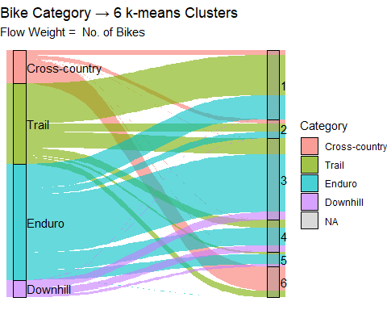
####3D plot
# # This is for the wrong clusters atm, k4 is for 2 PCs but is being plotted for sub3 (3 PCs)
#
# plot_ly(data = clustering_sub3, x = ~PC1, y = ~PC2, z = ~PC3, color = ~factor(k4$cluster),
# colors = c("#E41A1C", "#377EB8", "#4DAF4A"), type = "scatter3d", mode = "markers") %>%
# layout(title = "3D PCA space - k = 3 clusters")

Mixed clustering

Mixed dataframe creation
# mixed_df: data.frame with numeric columns and categorical columns as factors
# id_cols <- c("Brand", "Model", "Year", "Motorized", "Wheel.Size") # all categorical columns in mtbgeo
id_cols <- c("Brand", "Year", "Motorized", "Wheel.Size") # subset of categories from industry expert
mixed_df <- cbind(
mtbgeo[, intersect(id_cols, names(mtbgeo)), drop = FALSE],
as.data.frame(mtbgeo[, strong_vars]) # use subset of strong vars -> don't need to use standaridised ones
)
# head(mixed_df)
# mixed_df$Brand = as.factor(mixed_df$Brand) # need to turn these categorical variables into clusters
# mixed_df$Model = as.factor(mixed_df$Model)
# mixed_df$Motorized = as.factor(mixed_df$Motorized)
# mixed_df$Year = as.factor(mixed_df$Year)
# mixed_df$Wheel.Size = as.factor(mixed_df$Wheel.Size)
# Ensure types are correct
mixed_df[] <- lapply(mixed_df, function(x) if (is.character(x)) factor(x) else x)
mixed_df$Year = as.factor(mixed_df$Year)
head(mixed_df)
## Brand Year Motorized Wheel.Size Reach Head.Tube.Angle
## 54 Alchemy 2022 false 29″ 454 65.0
## 65 Alutech 2021 true Mullet 29/27,5 450 64.0
## 68 Alutech 2022 true Mullet 29/27,5 450 63.5
## 81 Alutech 2022 false 29″ 440 64.0
## 85 Alutech 2015 false 27,5″ / 650B 433 65.4
## 90 Alutech 2019 false 27,5″ / 650B 440 65.0
## Seat.Tube.Angle.Effective Head.Tube.Length Seat.Tube.Length Wheelbase
## 54 75.5 90 425 1197
## 65 76.5 110 435 1214
## 68 76.5 110 435 1214
## 81 75.0 110 430 1222
## 85 75.0 110 440 1181
## 90 75.0 110 420 1192
## Bottom.Bracket.Offset
## 54 60
## 65 9
## 68 9
## 81 30
## 85 9
## 90 9
###Finding optimal k for mixed
fit_kproto <- function(k, df, nstart, d_gower) {
fit <- suppressMessages(suppressWarnings( kproto(df, k = k, nstart = nstart) ))
sil_mean <- NA
if(!is.null(d_gower) && k > 1) {
sil_mean <- silhouette(as.integer(fit$cluster), d_gower)[,3]
}
fit_df <- data.frame(k = k, tot_withinss = fit$tot.withinss, # k-prototypes TWSS (lower is better)
lambda = fit$lambda, # balance used
sil_mean = sil_mean)
return(fit_df)
}
kproto_sweep <- function(df, k_range, nstart = 20, seed = 123, do_silhouette = TRUE) {
set.seed(seed)
d_gower <- NULL
if (do_silhouette) {
d_gower <- daisy(df, metric = "gower") # Compute Gower for silhouettes (optional)
}
k_sweep <- lapply(k_range, fit_kproto, df = df, nstart = nstart, d_gower = d_gower)
df_out <- bind_rows(k_sweep) # “Explained dissimilarity” relative to k=1
df_out <- df_out %>%
mutate(tot_withinss_k1 = first(tot_withinss),
explained = 1 - (tot_withinss / tot_withinss_k1))
return(df_out)
}
plot_mixed_elbow <- function(mixed_sweep) { # Elbow plot for k-prototypes
ggplot(mixed_sweep, aes(k, tot_withinss)) +
geom_line(color="steelblue") + geom_point(color="steelblue") + theme_classic() +
scale_x_continuous(breaks = 1:10) +
labs(title = "k-prototypes elbow (total within-cluster dissimilarity)",
x = "k", y = "Total withinss (lower is better)")
}
plot_mixed_exp_diss <- function(mixed_sweep) { # explained dissimilarity in % (relative to k=1)
ggplot(sweep_df, aes(k, explained)) +
geom_line(color="steelblue") + geom_point(color="steelblue") + theme_classic() +
scale_y_continuous(labels = scales::percent_format()) +
labs(title = "Explained dissimilarity vs k",
x = "k", y = "Explained dissimilarity")
}
# Optional: silhouette (using Gower) to corroborate elbow
plot_mixed_silhouette <- function(mixed_sweep) {
ggplot(filter(mixed_sweep, k > 1), aes(k, sil_mean)) +
geom_line(color="steelblue") + geom_point(color="steelblue") + theme_classic() +
labs(title = "Average silhouette vs k (Gower distance)",
x = "k", y = "Average silhouette")
}
# Run the sweep
ks <- 1:10
sweep_df <- kproto_sweep(mixed_df, k_range = ks, do_silhouette = TRUE)
## 0 0
## 0 observation(s) with NAs.
p1 <- plot_mixed_elbow(sweep_df)
p2 <- plot_mixed_exp_diss(sweep_df)
p3 <- plot_mixed_silhouette(sweep_df)
p1
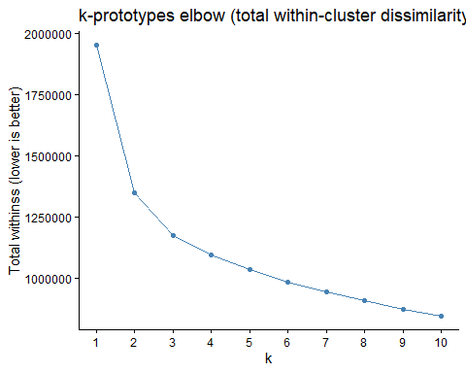
p2
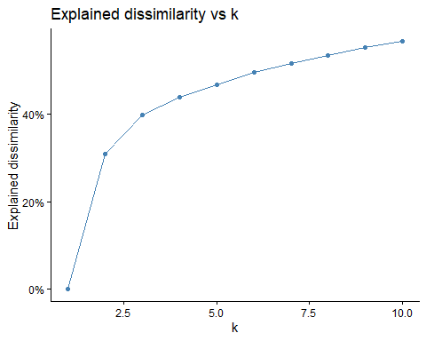
# grid.arrange(grobs = c(p1,p2,p3), ncol = 3)
###Optimal k for mixed
# k-prototypes (handles mixed types)
set.seed(123)
kmix3 <- kproto(mixed_df, k = 3, lambda = NULL, nstart = 20)
## # NAs in variables:
# lambda = NULL => auto-estimated balance between numeric and categorical parts
# kmix$centers # data frame: numeric columns are means; factors are modes
# kmix$lambda # numeric↔categorical balance used
# kmix$size # cluster sizes
# kmix$withinss # within-cluster dissimilarity per cluster
# kmix$tot.withinss # total within-cluster dissimilarity
# summary(kmix)
kmix3
## Distance type: huang
##
## Numeric predictors: 7
## Categorical predictors: 4
## Lambda: 485.2853
##
## Number of Clusters: 3
## Cluster sizes: 281 118 211
## Within cluster error: 479840.8 239929.7 455828.3
##
## Cluster prototypes:
## Brand Year Motorized Wheel.Size Reach Head.Tube.Angle
## 1 Cube 2021 false 29″ 449.2707 65.11726
## 2 Cube 2022 false 29″ 435.2924 67.49661
## 3 Canyon 2022 false 29″ 457.8588 64.09773
## Seat.Tube.Angle.Effective Head.Tube.Length Seat.Tube.Length Wheelbase
## 1 76.08875 107.2420 418.3370 1208.628
## 2 74.56186 105.5847 431.7458 1154.164
## 3 76.72848 111.4976 420.5583 1246.169
## Bottom.Bracket.Offset
## 1 28.05932
## 2 43.79407
## 3 18.15450

Plotting optimal ks for mixed
kmix <- kmix3
# kmix <- kmix4
# kmix <- kmix6
mixed_plots <- clustMixType::clprofiles(kmix, mixed_df)
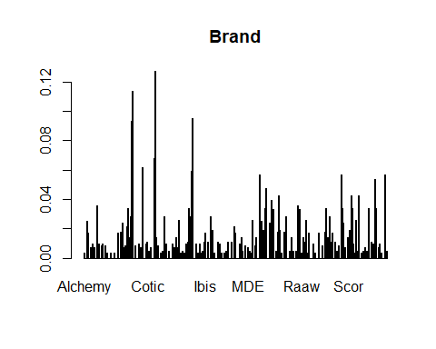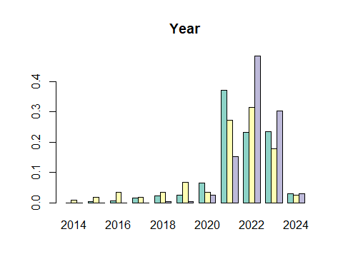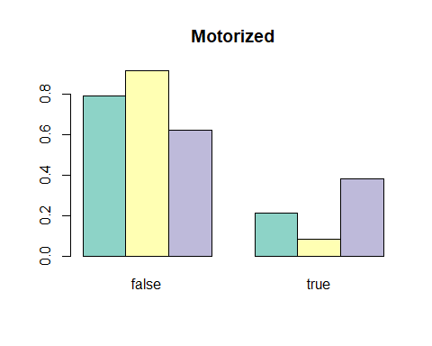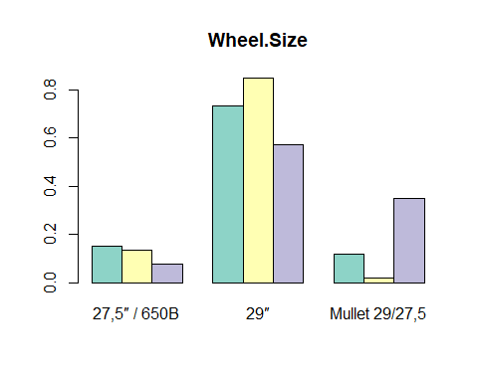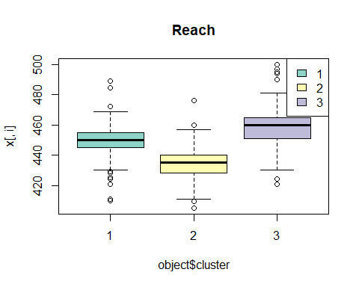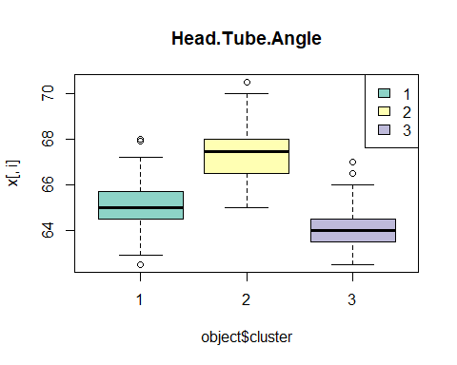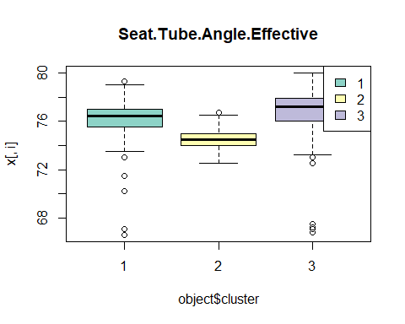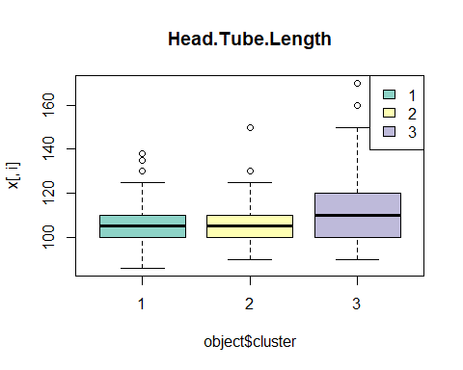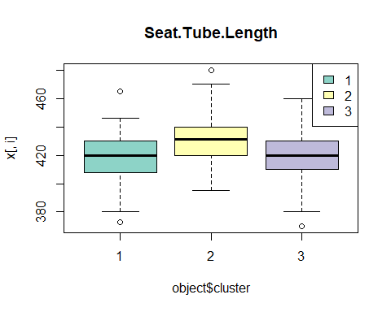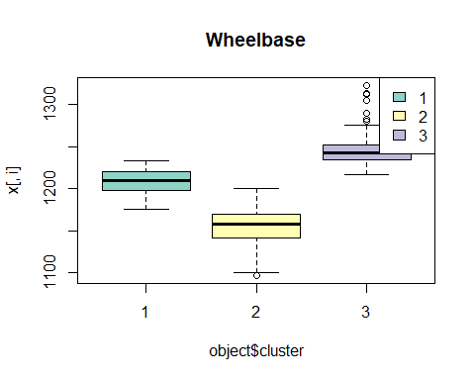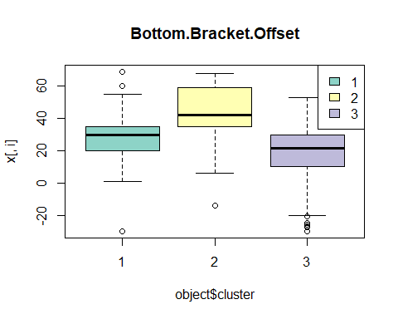
mixed_with_pc <- mixed_df
mixed_with_pc$PC1 <- pca$scores[,"Comp.1"]
mixed_with_pc$PC2 <- pca$scores[,"Comp.2"]
mixed_with_pc$Category <- factor(mtbgeo_groups$Category, levels = c("Cross-country", "Trail", "Enduro", "Downhill"))
mixed_with_pc$kproto <- factor(kmix$cluster)
mixed_with_pc$kmeans <- factor(results$k3$cluster)
# mixed_with_pc$kmeans <- factor(results$k4$cluster)
# mixed_with_pc$kmeans <- factor(results$k6$cluster)
plot_df <- data.frame(x = mixed_df[,"Reach"],
y = mixed_df[,"Wheelbase"],
cluster = factor(kmix$cluster))
ggplot(plot_df, aes(x, y, color = cluster)) +
geom_point(alpha = 0.8) +
labs(title = "k-prototypes clusters on Reach vs Wheelbase", x = "Reach", y = "Wheelbase") +
stat_ellipse(aes(fill = cluster, group = cluster), type = "norm", geom = "polygon", level = 0.9, linewidth = 0.8, alpha = 0.25) +
theme_classic()
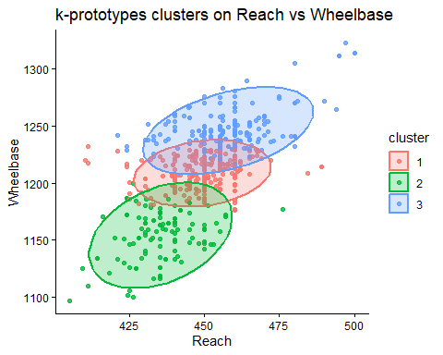
# p_kproto <- ggplot(mixed_with_pc, aes(PC1, PC2, color = factor(kmix$cluster), shape = Category)) +
p_kproto <- ggplot(mixed_with_pc, aes(PC1, PC2, color = kproto)) +
geom_point(alpha = 0.8) +
# scale_shape_manual(values = c(16, 17, 15, 3)) +
stat_ellipse(aes(fill = kproto, group = kproto), type = "norm", geom = "polygon", level = 0.9, linewidth = 0.8, alpha = 0.25) +
labs(title = "k-prototypes clusters on PC map: k = 6", color = "kproto") +
theme_classic()
#
# p_kmeans <- ggplot(mixed_with_pc, aes(PC1, PC2, color = kmeans)) +
# geom_point(alpha = 0.8) +
# stat_ellipse(aes(fill = kmeans, group = kmeans), type = "norm", geom = "polygon", level = 0.9, linewidth = 0.8, alpha = 0.25) +
# labs(title = "k-means clusters on PC map", color = "kmeans") +
# theme_classic()
# ggplot(mixed_with_pc, aes(PC1, PC2)) +
# geom_point(aes(color = kproto), alpha = 0.75, size = 1.8) +
# stat_ellipse(aes(color = kproto, group = kproto), type = "norm", level = 0.90, linetype = 1) +
# stat_ellipse(aes(color = kmeans, group = kmeans), type = "norm", level = 0.90, linetype = 2) +
# labs(title = "Ellipses: k-prototypes (solid) vs k-means (dashed)",
# color = "Cluster") +
# theme_minimal()
p_kproto
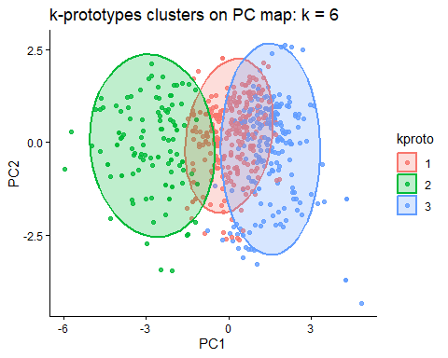
# p_kmeans
mixed_table <- bike_confusion_table(mixed_df, kmix)
mixed_table
## Category
## Cluster Cross-country Trail Enduro Downhill
## 1 8 131 135 7
## 2 73 41 4 0
## 3 0 27 148 36
bike_sankey(mixed_table, "Bike Category → 3 k-prototypes Clusters")
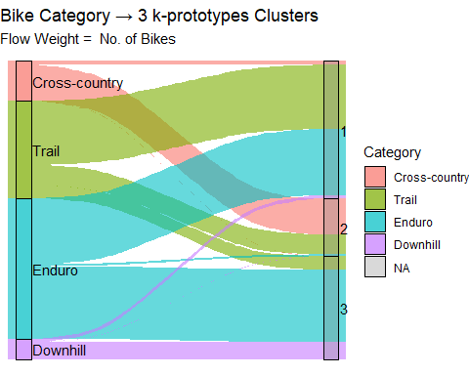

SVM - extra marks

Packages for SVM
# SVM: multi-class classification on numeric geometry-only features
# Extra packages required for this SVM section
library(e1071)
##
## Attaching package: 'e1071'
## The following object is masked from 'package:ggplot2':
##
## element
library(caret)
## Loading required package: lattice
library(lattice)

Dataframe with labels
set.seed(1234)
# Build labelled data frame: X = geometry vars only, y = Category from mtbgeo_groups
feature_names <- names(mtbgeo)[geo_vars]
svm_df <- mtbgeo[, feature_names, drop = FALSE] %>%
mutate(Category = factor(mtbgeo_groups$Category))

Split into Train/Test
# Stratified train/test split as classes are imbalanced and we need them all represented in train and test sets
idx <- caret::createDataPartition(svm_df$Category, p = 0.7, list = FALSE)
train <- svm_df[idx, ]
test <- svm_df[-idx, ]

Add class weights
# Compute class weights to address imbalance (median frequency scaling)
freq <- table(train$Category)
class_wts <- as.numeric(median(freq) / freq)
names(class_wts) <- names(freq)
freq
##
## Cross-country Trail Enduro Downhill
## 57 140 201 31

Hyperparameter tuning for Gamma and Cost
# Hyperparameter tuning (radial kernel)
gamma_grid <- 2^(-9:-1) # reasonable range for gamma (RBF width)
cost_grid <- 2^(-1:9) # reasonable range for C (regularisation)
# try every (C, gamma) pair on 5 fold CV on training data
tuned <- e1071::tune.svm(
x = train[, feature_names],
y = train$Category,
kernel = "radial",
gamma = gamma_grid,
cost = cost_grid,
class.weights = class_wts,
scale = TRUE, # safe standardisation inside svm
tunecontrol = tune.control(cross = 5) # 5-fold CV
)
# note to team: this will take a bit to find best
best <- tuned$best.model # gets best (C, gamma) found by CV
best
##
## Call:
## best.svm(x = train[, feature_names], y = train$Category, gamma = gamma_grid,
## cost = cost_grid, class.weights = class_wts, kernel = "radial",
## scale = TRUE, tunecontrol = tune.control(cross = 5))
##
##
## Parameters:
## SVM-Type: C-classification
## SVM-Kernel: radial
## cost: 256
##
## Number of Support Vectors: 182
best$cost; best$gamma # confirm what's in the final model
## [1] 256
## [1] 0.03125

Get Predictions
# Test-set predictions
pred <- predict(best, newdata = test[, feature_names])

Validation visualisations

Confusion Matrix
# Confusion matrix
cm <- caret::confusionMatrix(pred, test$Category)
cm
## Confusion Matrix and Statistics
##
## Reference
## Prediction Cross-country Trail Enduro Downhill
## Cross-country 23 9 0 0
## Trail 0 43 13 1
## Enduro 1 7 68 4
## Downhill 0 0 5 7
##
## Overall Statistics
##
## Accuracy : 0.779
## 95% CI : (0.7115, 0.8372)
## No Information Rate : 0.4751
## P-Value [Acc > NIR] : < 2.2e-16
##
## Kappa : 0.6649
##
## Mcnemar's Test P-Value : NA
##
## Statistics by Class:
##
## Class: Cross-country Class: Trail Class: Enduro
## Sensitivity 0.9583 0.7288 0.7907
## Specificity 0.9427 0.8852 0.8737
## Pos Pred Value 0.7188 0.7544 0.8500
## Neg Pred Value 0.9933 0.8710 0.8218
## Prevalence 0.1326 0.3260 0.4751
## Detection Rate 0.1271 0.2376 0.3757
## Detection Prevalence 0.1768 0.3149 0.4420
## Balanced Accuracy 0.9505 0.8070 0.8322
## Class: Downhill
## Sensitivity 0.58333
## Specificity 0.97041
## Pos Pred Value 0.58333
## Neg Pred Value 0.97041
## Prevalence 0.06630
## Detection Rate 0.03867
## Detection Prevalence 0.06630
## Balanced Accuracy 0.77687

Accuracy scores
# Per-class precision/recall/F1
per_class_metrics <- {
lev <- levels(test$Category)
res <- lapply(lev, function(l) {
tp <- sum(test$Category == l & pred == l)
fp <- sum(test$Category != l & pred == l)
fn <- sum(test$Category == l & pred != l)
precision <- ifelse(tp + fp == 0, NA, tp / (tp + fp))
recall <- ifelse(tp + fn == 0, NA, tp / (tp + fn))
f1 <- ifelse(
is.na(precision) | is.na(recall) | precision + recall == 0,
NA,
2 * precision * recall / (precision + recall)
)
data.frame(class = l, precision, recall, f1)
})
do.call(rbind, res)
}
accuracy <- mean(pred == test$Category)
print(per_class_metrics)
## class precision recall f1
## 1 Cross-country 0.7187500 0.9583333 0.8214286
## 2 Trail 0.7543860 0.7288136 0.7413793
## 3 Enduro 0.8500000 0.7906977 0.8192771
## 4 Downhill 0.5833333 0.5833333 0.5833333

Confusion Heatmap
# Confusion heatmap
cm_df <- as.data.frame(table(Truth = test$Category, Pred = pred))
ggplot(cm_df, aes(x = Pred, y = Truth, fill = Freq)) +
geom_tile() +
geom_text(aes(label = Freq), size = 4) +
labs(title = "SVM confusion matrix (test set)", x = "Predicted", y = "True") +
theme_classic(base_size = 13) +
scale_fill_gradient(name = "Count", low = "grey95", high = "steelblue4")
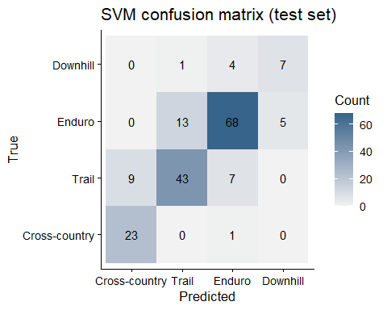

Decision Regions in PCA space
# PCA on train dataset only
Xtr <- train[, feature_names]
pcs <- princomp(Xtr, cor = TRUE, scores = FALSE)
# 2 = k PCs (This is just for plotting so no need to align with actual PCA and we just train SVM on the first two)
var_expl <- pcs$sdev^2 / sum(pcs$sdev^2)
k <- 2
# project train/test to PC space
train_scores <- as.data.frame(predict(pcs, newdata = Xtr)[, 1:k])
test_scores <- as.data.frame(predict(pcs, newdata = test[, feature_names])[, 1:k])
train_scores$Category <- train$Category
test_scores$Category <- test$Category
# Train SVM on PC1, PC2
svm_pca <- e1071::svm(Category ~ ., data = {
sc <- as.data.frame(predict(pcs, Xtr)[, 1:2])
sc$Category <- train$Category
sc
}, kernel = "radial", gamma = best$gamma, cost = best$cost,
class.weights = class_wts, scale = TRUE)
# Decision regions grid
ts2 <- as.data.frame(predict(pcs, test[, feature_names])[, 1:2])
names(ts2) <- c("Comp.1","Comp.2")
rng1 <- range(ts2$Comp.1); rng2 <- range(ts2$Comp.2)
grid <- expand.grid(`Comp.1` = seq(rng1[1], rng1[2], length.out = 200),
`Comp.2` = seq(rng2[1], rng2[2], length.out = 200))
grid$pred <- predict(svm_pca, grid)
ggplot() +
geom_raster(data = grid, aes(`Comp.1`, `Comp.2`, fill = pred), alpha = 0.25) +
geom_point(data = transform(ts2, Category = test$Category),
aes(`Comp.1`, `Comp.2`, colour = Category), size = 1.8) +
labs(title = "SVM decision regions in PCA space") +
theme_classic(base_size = 13) +
guides(fill = "none")
